

t

Module Explanation

DATE \@ "dddd, dd MMMM yyyy" Tuesday, 25 March 2025
Friday, 06 February 2026

Disclaimer
Kyriba operates in a dynamic environment and our technology offering is subject to change. The information contained herein is for informational purposes only and is not a commitment, promise, or legal obligation to deliver any material, code, or functionality. The technology described remains at our sole discretion. Kyriba reserves the right to modify all or part of our technology infrastructure at any time depending on client needs, market dynamics, and technological advances.
Contents

Disclaimer 2
Contents 3
I. Introduction 6
II. Treasury Management 7
Cash and Liquidity Management 8
1. Cash Management and Forecasting [also in Kyriba for Mid-Market] 8
2. In House banking [also in Kyriba for Mid-Market] 8
3. Cash Accounting [also in Kyriba for Mid-Market] 9
4. GL Reconciliation [also in Kyriba for Mid-Market] 9
5. Liquidity Planning 10
Bank Relationship Management 11
1. Bank Account Management 11
2. Bank Fee Analysis 11
Data and Analytics for Cash 12
1. Cash Analytics 12
2. Cash Management AI 12
Other notable options 14
1. Bank Statement Forwarding 14
2. [Connectivity] Bank Reporting - Concentrator [also in Kyriba for Mid-Market] 14
3. Market Data (Standard) [also in Kyriba for Mid-Market] 15
4. Market Data export 15
5. Blackrock Money Market Connector 16
6. ICD Money Market Integration 17
7. Goldman Sachs Mosaic Integration 17
III.Trusted AI (TAI)
IV Payments 19
Payment Management 20
1. Payments [also in Kyriba for Mid-Market] 20
2. Payment Factory [also in Kyriba for Mid-Market] 20
3. Direct Debit [also in Kyriba for Mid-Market] 21
4. SEPA Mandates [also in Kyriba for Mid-Market] 21
5. Netting 21
6. Draft Payables 22
7. Draft Receivables 23
8. Payment Builder 24
Fraud Management 25
1. Fraud Detection 25
2. Fraud Screen data volume 25
3. Payment Screening 26
4. Payment Anomaly detection using Machine Learning 26
5. Bank Account Validation 27
Data and Analytics for Payment, Fraud and Compliance 28
1. Payment Analytics 28
2. Compliance Analytics 28
Other notable options 29
1. Control Center 29
2. SWIFT Bank Directory Plus 30
3. Bank Payments - Concentrator [also in Kyriba for Mid-Market] 30
4. Payment: Digital Signature [also in Kyriba for Mid-Market] 30
5. Multi-Factor Authentication [also in Kyriba for Mid-Market] 31
IV. Risk Management 32
Risk Management and Financial Transactions 33
1. Position Keeping [also in Kyriba for Mid-Market] 33
2. EMIR Reporting 33
3. Valuation 34
4. Hedge Accounting 34
5. Financial Accounting 35
6. Risk Analysis 36
7. Credit Risk 36
8. Leases 37
FX Exposure Management - Balance Sheet 38
1. Balance Sheet Base Platform 38
FX Exposure Management - Cash Flow 38
1. Cash Flow Base Platform 38
Data and Analytics for Risk 39
1. Risk Analytics 39
2. Liquidity Analytics 39
Other notable options 40
1. Premium Market Data 40
2. Premium Market Data for Risk 40
3. Premium Market Data for advanced Risk 41
4. Advanced FX Valuation – FinCAD 42
5. Advanced Interest Rates Valuation – FinCAD 42
6. Premium Cap/Floor Implied Volatilities 43
7. CaaS Connector - CME Datamine Term SOFR 43
V. Working Capital 44
Trade Solutions 45
1. Reverse Factoring 45
2. Reverse Factoring - Financing Fees 46
3. Dynamic Discounting 46
4. Dynamic Discounting - Discount Earning Fees 47
5. Receivables Finance - Core 47
6. Receivables Finance - Discount Earning Fees 47
Supplier On boarding Solutions 48
1. Supplier Onboarding - Web site 48
2. Supplier Onboarding - Emailing 48
3. Supplier Onboarding - Reporting 49
Data and Analytics for Working Capital 50
1. SCF Analytics 50
VI. Connectivity Solutions 51
Bank Connectivity 51
1. Bank Reporting - Concentrator [also in Kyriba for Mid-Market] 51
2. Bank Reporting [also in Kyriba for Mid-Market] 51
3. Bank Payments [also in Kyriba for Mid-Market] 52
4. Bank Payments - Concentrator [also in Kyriba for Mid-Market] 52
5. SWIFTNET Service Bureau 52
6. SWIFTNET AL2 Service [also in Kyriba for Mid-Market] 53
7. Local and regional networks subscriptions: FIRST, Editran, CBI, BACS, China 53
8. Advanced Bank Payments Connector 54
9. Advanced Bank Reporting Connector 54
ERP Connectivity 57
1. ERP Connector - SAP 57
2. ERP Connector - Oracle 57
3. NetSuite API Connector [also in Kyriba for Mid-Market] 58
4. ERP Connector - Dynamics 365 Finance 58
API-based value-add connectors 60
1. API Platform 60
2. Open Reports Studio 60
3. Technical Process Token 61
Setup and Impact fees 62
1. SWIFTNET Setup 62
2. SWIFTNET AL2 Setup [also in Kyriba for Mid-Market] 62
3. Bank Reporting Volumes [also in Kyriba for Mid-Market] 62
4. ERP Transactions Volumes [also in Kyriba for Mid-Market] 62
5. Payment Volumes [also in Kyriba for Mid-Market] 62
VII. Additional Options 63
Architecture and Security 63
1. Sandbox 63
2. FTP Multi Context [also in Kyriba for Mid-Market] 63
3. Security Package [also in Kyriba for Mid-Market 64
4. Virtual Private Network (VPN) 66
Services 67
1. Multiple Support Centers 67
2. Premium Support 68
3. Platinum Support 68
4. Enhanced Security Services 69
VIII. Appendix 70
1. Kyriba for Mid-Market and Kyriba Enterprise solution scope differences 70
2. List of all modules currently available in Kyriba 74

- Introduction
Kyriba is pleased to provide a Module Explanation document in relation to [Company]’s (“[Company abbr]”) selection and implementation of a new Liquidity Performance Platform.
The intention of this review document is to further explain the Kyriba functions, modules and outputs related to [Company]’s Order Schedule produced by Kyriba. This non-contractual document includes functional explanations of individual options and modules as set out in the Kyriba documents alongside related user rights.
As highlighted in your attached Order Schedule, please note the components of a standard Kyriba subscription are as follows:
- Bundles and Modules – in line with [Company]’s requirements and not beyond. All bundles, add-on modules and wider options are listed in the current document;
- Number of Users: each bundle requires user licenses which can turn on services for all modules to licensed users, in a given bundle;
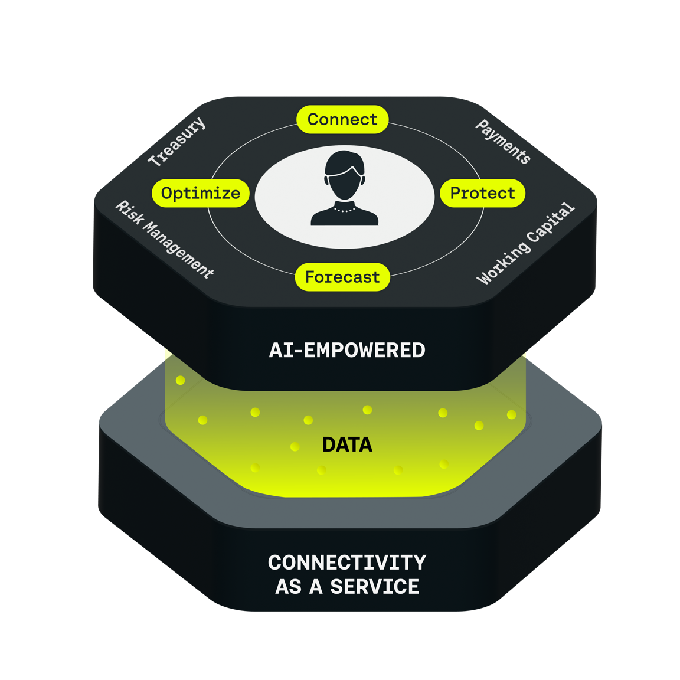
- Bank Connectivity – based on the number of unique connections and anticipated transactions volumes. A set of numbers is included in each bundle.

Please also note an extensive definition of the content of Kyriba for Mid-Market offering (in comparison to the standard extensive Kyriba Enterprise solution) is available in appendix.
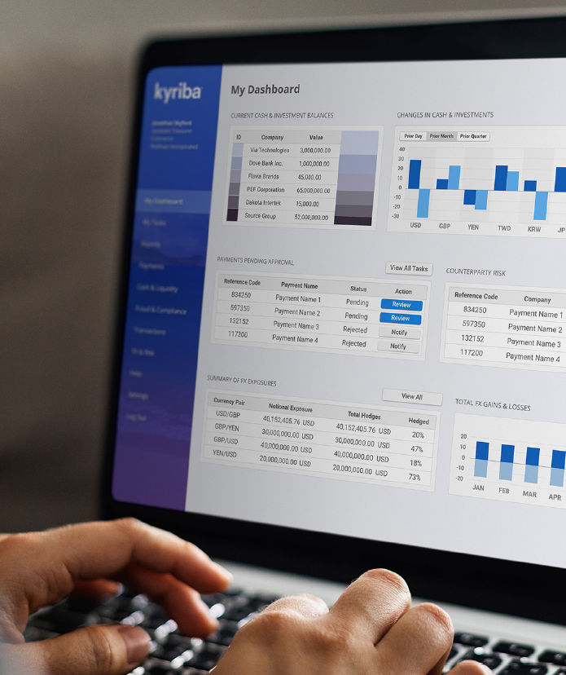
- Treasury Management

Kyriba provides CFOs and treasurers with a complete Treasury Management solution suite that includes cash management, forecasting, bank management, netting and pooling, debt and investment financial instrument workflows, along with accounting integration to General Ledger for cash and financial instrument accounting journal entries.
Kyriba Cash and Liquidity Management module provides visibility into the organization’s cash. Kyriba delivers timely and accurate global cash visibility, across all banks, in all regions, and enables treasury teams to create accurate forecasts that deliver confidence throughout the organization. Kyriba’s Cash Management and Forecasting capabilities automate the preparation and reconciliation of the organization’s daily cash position. Clients can further use Kyriba’s cash forecasting functions to build and analyse cash forecasts prospectively and retrospectively by leveraging multiple sources of data, including repetitive items, import of ERP data, integration with other Kyriba modules, and extrapolation of historical data.
As part of its embedded complementary liquidity solutions, Kyriba’s In-House Banking module allows organizations to track and report intercompany transactions, accounts and facilities between a parent company and its subsidiaries to help organizations pool cash and more efficiently borrow, invest or hedge exposures. Kyriba Cash Accounting further eliminates the time consuming effort and error-prone manual process of posting to popular General Ledger systems by automating the accounting process, generating dual and multi-sided entries from bank and internal cash transactions. Kyriba GL Reconciliation finally automates the bank-to-book reconciliation process by reconciling bank transactions to accounting entries, providing organizations with improved productivity and reduced exposure to the risk of errors.
Kyriba Treasury Management solution thrives to provide CFOs and treasurers with the visibility and reporting they need to optimize cash returns, control bank accounts, drive reporting and compliance, and manage liquidity.
Cash and Liquidity Management
- Cash Management and Forecasting
Kyriba Cash management and Forecasting provide a flexible process in which bank and forecast data can be combined within client-defined Dashboards, Worksheets and Reports to produce multi-currency cash position reporting.
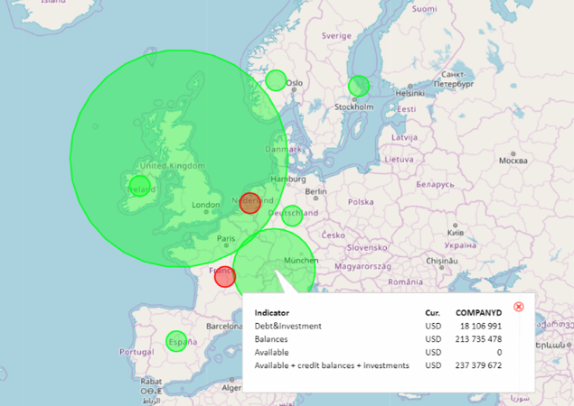
Kyriba further allows client-specific cash forecast information to be collected, analysed and reported. Cash forecast can be captured by standardized customisable screen templates, import as well as in-line table data entry.
Kyriba manages Zero-Balancing Arrangements, sweeping and notional pooling structures actively and passively. System-initiated automated transfers of excess funds at the end of day are based upon user-defined target and threshold balances.
Sources of data include bank statements, forecast capture, forecast import from ERP and third party systems, financial forecast from deals or payment transactions, and invoice level cash flows from supply chain finance contracts (where applicable).
Applicable functions include actuals and forecast import/enrichment, bulk modification of cashflows, n-to-n reconciliation of items between forecast and actuals, manual pool transfers recording, sweeps and notional pools calculations/transfers creation; single-period forecast variance reporting,
all cashflow and balance reporting, liquidity
reporting, cashflow reporting template setup
and administration.

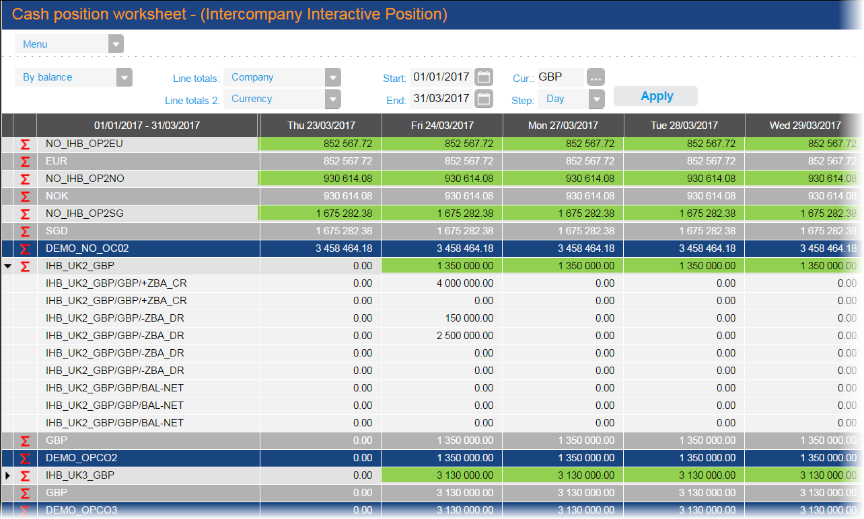
- In House banking
Kyriba is used to capture business units’ dealing (funding, financing, investment, FX, hedging) requests, to commit requests, update positions and post entries to the corresponding internal or external bank accounts as specified by the internal relationships setup in Kyriba. Interest rates may be assigned for the calculation of arm’s length interest income or expense on each in-house account and transaction, should Treasury apply an in-house bank service fee or margin. By capturing business units’ in-house (loan) accounts balances, transactions and interest tier templates, Kyriba allows for effective strategic reporting services to its business units.
Sources of data include bank statements (for in-house and subsidiaries' account impact), in-house bank account transaction capture, forecast import from ERP and third party systems, financial forecast from intercompany deals or on-behalf payment transactions (where applicable).
Applicable functions include waterfall-model transfers creation on in-house bank accounts, interest accrual and payable calculation, withholding and other taxes calculation on internal accounts, in-house bank statement creation, internal deal portfolio management.
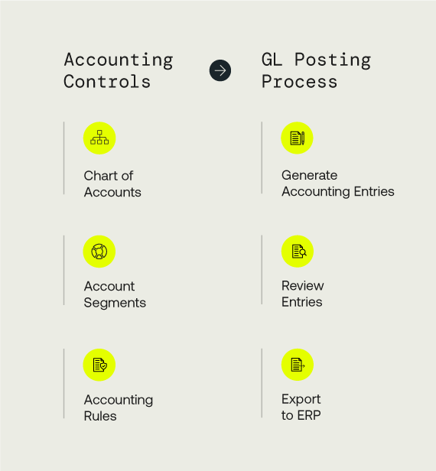
- Cash Accounting
Kyriba’s Cash Accounting Module automates the unattended process of creating GL entries based on actual bank and forecast cash transactions. Kyriba’s Cash Accounting ledger flexibility allows the mapping of business and holding entities’ ledgers to a standardized general ledger fed by flow-based rules (e.g. fees, charges, payments, interests, amortisation amounts).
Kyriba creates ERP-agnostic cash accounting journal entries utilizing repetitive controlled business rules. Generated postings can be reviewed and validated before being securely exported to one or multiple ERPs in compliant formats.
Sources of data include bank statements, operational forecast, financial forecast, payment all from within Kyriba.
Applicable functions include frequent accounting entries creation, approval and export; month-end hard-closure and P&L account revaluation; ledger and trial balance reporting.

- GL Reconciliation
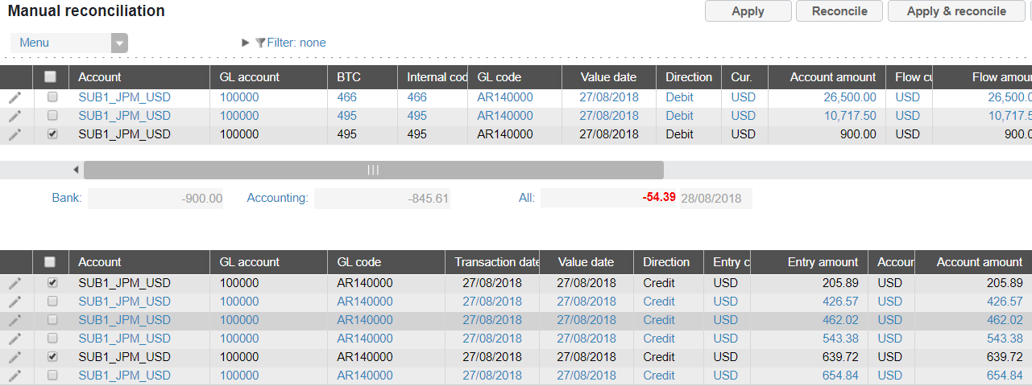
Kyriba’s GL Reconciliation is a solution to some ERPs’ shortfall to reconcile effectively bank to accounting transactions, at both line item and total levels. Accounting balances are stored in Kyriba, by account and date. Kyriba performs unattended and on-demand matching between bank information data (uploaded once from daily statements) and GL entries, ensuring that the same transactions exist on both sides. Matching can be one-to-one, one-to-many, many-to-one, or many-to-many. Potential discrepancies (e.g. checks and other delayed payments) can be easily managed via Kyriba’s Balance Control Reports and tagged in report to
end users.
Sources of data include bank statements already imported in Kyriba and accounting entries imported from the GL or ERP system(s).
Applicable functions include reconciliation rules setup, n-to-n automated reconciliation of items between postings and bank actuals, manual reconciliation matrix; scheduled accounting adjustments creation, approval and export; bank-to-book variance, balances and transactions reconciliation summary, ledger and trial
balance reporting.
- Liquidity Planning
Kyriba’s Liquidity Planning consolidates forecast planning, by integrating FP&A, Treasury, A/P and A/R to extend forecast horizons by at least 12 months to more efficiently reach Free Cash Flow objectives. It simultaneously manages multiple cash forecasts in parallel and models against liquidity planning and
risk scenarios.
Applicable functions include
- Handling of multiple forecast cycles in parallel: multi year, monthly over a year, weekly, daily, forecasts by date…
- Personalized structure of liquidity plans, including calculation formulae that replicate legacy Excel forecasting reports
- Quick creation of forecasts at Entity & Budget category levels
- Fast reforecasting and ability to edit multiple versions in parallel
- Spreadsheet-like entry
- Imports and itemization of forecasts for the same period/budget code
- Automatic loading of forecasts from other Kyriba products (debt schedule…)
- AI-generated forecasts (upcoming in 2023)
- “What If” scenarios that assess the impact of amount/percentage/period changes on cash & liquidity
- Reforecast submission workflow that clarifies the status of each version by entity
- Comment workflow for individual forecasts (upcoming in 2023)
- Consistency check of Intercompany forecasts
- Variance analysis reporting
- Payment term analysis reporting
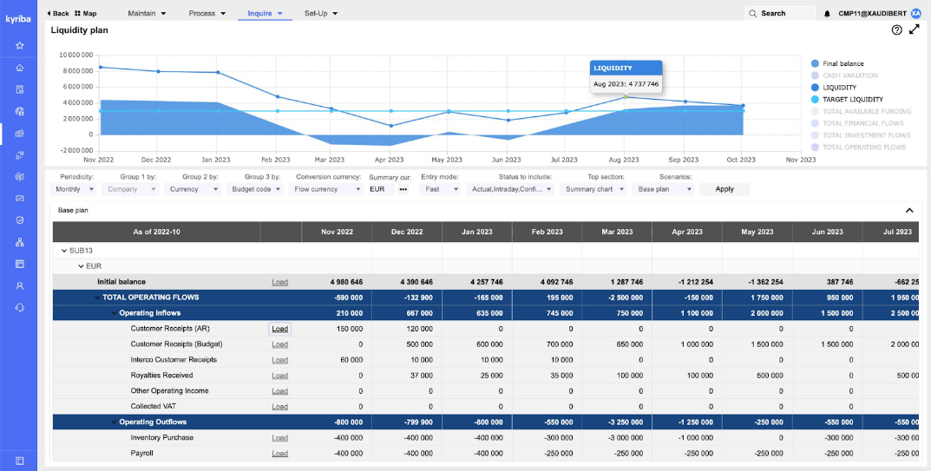
Bank Relationship Management
- Bank Account Management
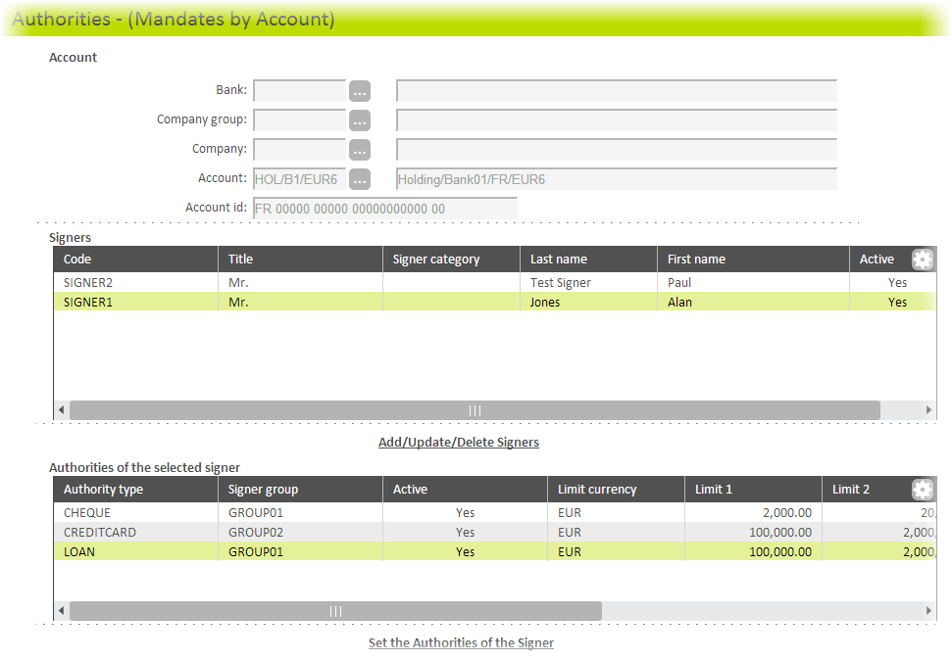
Kyriba’s Bank Account Management tracks in a workflow manner all details of all relevant bank accounts, signatories and numbered mandates. Users are able to approve and manage signature authorities for all accounts, and produce the appropriate management, bank, and compliance reporting, including country-specific bank templates, internal power of attorneys’ updates
and FBAR.
Sources of data include static data and payment module (where applicable).
Applicable functions include the import, capture and approval of accounts, signatories and mandates; reporting of all BAM items in standardised and templated (e.g. FBAR) formats.

- Bank Fee Analysis
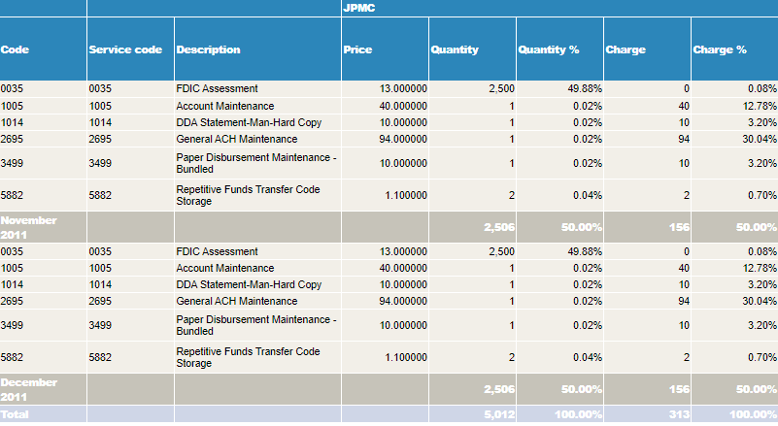
Kyriba’s Bank Fee Analysis module enables Treasuries to analyse and reconcile bank fees statements. Fee analysis statements in TWIST BSB 3.1, EDI822 or SWIFT camt.086.001 format can be automatically imported and categorized using pre-loaded bank specific service codes while contractual service pricing are setup in Kyriba. Kyriba’s BFA module highlights bank services being used per account, respective charges per service and their comparison against internal benchmarks.
Sources of data include bank fee statements, static data and fee-related cashflows.
Applicable functions include the import of bank fee statements (in the aforementioned formats); variance reporting between actual and contractual fees, matrix and graphical representation of actual fees; setup of fee terms and conditions, reporting categories and mapping with existing fee flow data.

Data and Analytics for Cash
- Cash Analytics
Kyriba's BI tool enables users to effectively analyse and optimise their strategic decision-making by delivering actionable insights and capabilities that unlocks value within the Kyriba treasury-related data. It elevates communication and strategic value, by increasing shareable insights, transforming data into information and reducing the time to research information in several locations.
Cash Analytics is a customer-specific data warehouse with a business-orientated data model dedicated to analysis. It stores historical over years and decades. Its embedded reporting is composed of cross-domain tables, views, measures and ready-made Key Performance Indicators. Cash analytics also delivers cross-domain customer-definable views, drag-and-drop abilities, advanced formulae, best-of-breed graphics, report package design and fully interactive dashboards.
Sources of data include data from the Cash Management and Forecasting, Advanced Forecasting, In-House banking and static data modules.
Applicable functions include nine (9) off-the-shelf views:
- Overview
- Do I have enough cash? (including cash balance impact, projections vs forecast, balances vs forecast)
- What is the performance of my affiliates? (including cash performance by subsidiary, time and geography)
- Are my forecasts reliable? (including projections vs forecast by budget code, variance trends, deviation)
- Are my forecasts consistent with the past? (including actuals vs forecast, subsidiary contribution)
- Are my cashflows well identified? (including unidentified cashflow proportion, quality improvement over time, quality control performance by subsidiary and country)
- What is my activity with banks? (including turnover by bank country, evolution of turnover over time, by bank)
- What are the details of my cash flows? (including a cashflow pivot table with on-screen filters)
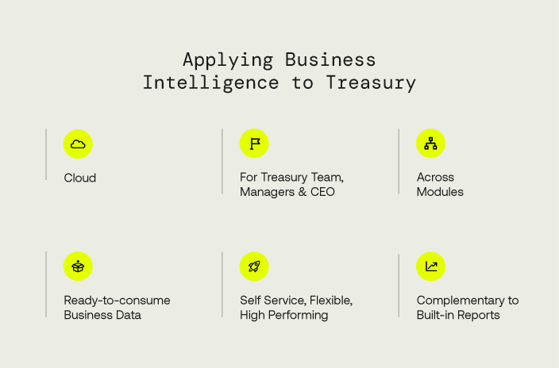
- Application content (including statistics about the whole BI for cash)
Licensed Cash users have access to all 9 standard views in read-only mode and other personalised views in read-and-write mode.

- Cash Management AI
Cash Management AI is a Business Intelligence App with Artificial Intelligence-powered forecasting of cash flows and balances. This AI app is using customer's own cashflow history to learn about their specific cashflow seasonality, trends and repetitive changes, and then to predict the future inflows, up to a week in the future. It combines the predicted inflows with Kyriba-stored cash outflow plan ("confirmed forecast") to show the integrated cash balance picture. This AI app helps to manage the cash cushion and the risk of short-term cash unavailability.
The ever-learning Artificial Intelligence model generates a prediction by currency and other dimensions. Users can select their desired confidence level. Predictive analytics are actionable in real time within the platform.
Sources of data include data from the Cash Management and Forecasting, and static data modules.
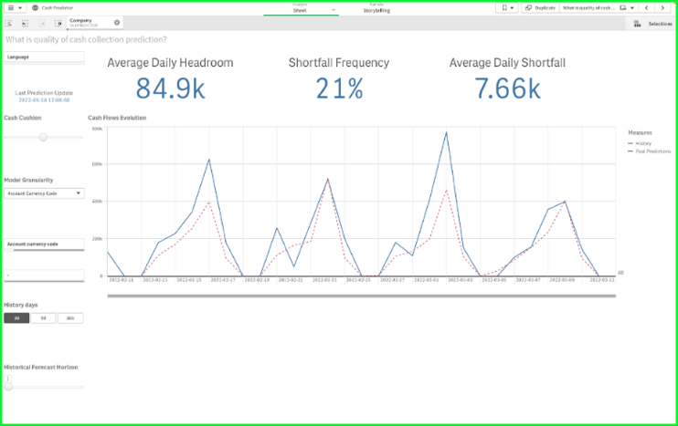
Applicable functions include five master sheets ("What will be my future balance?", "What will be my inflows?", "What will be my outflows?", "What is my risk profile?", "What is the quality of my cash collection prediction?"), 3 master KPIs (“average daily headroom”, “shortfall frequency” and “average daily shortfall”) a control to set and modify the Cash Cushion level, and a cashflow category filter.
Cash management AI does not require any user access or right to be setup. Licensed Cash Management AI users have access to all five standard views in read-only mode and other personalised views in read-and-write mode.

Other notable options
- Bank Statement Forwarding
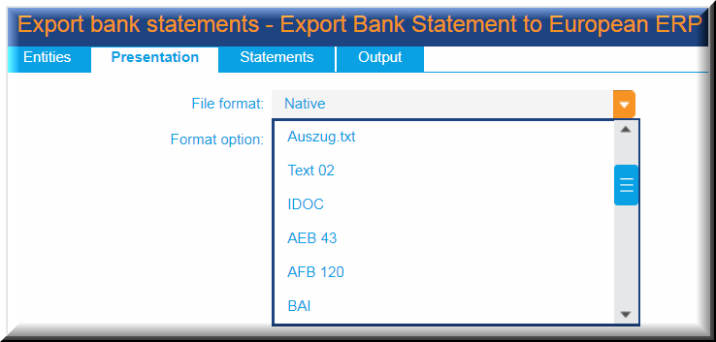
Kyriba includes a standard bank statement re-export process using the original format of any chosen statement or an embedded export in standard formats, such as SAP MultiCash, IDOC, MT940, CAMT and BAI.
Sources of data include imported bank
statements only.
Applicable functions include bank statement export and associated filters. This function is notably applicable to the purpose of bank statement export to third party GL system for alternative bank-to-book and bank-to-forecast reconciliation, as well as an alternative to Kyriba’s own cash accounting entries creation.

- [Connectivity] Bank Reporting - Concentrator
Kyriba’s Statement Concentrator (or “aggregator”) service stands for the import of prior and intra-day statements in MT940 and MT942 formats through Kyriba’s own BIC on the SWIFT network (BREDFRPPKYR for Europe, BREDFRPPKAS for Asia, BREDFRPPKUS for the US). Kyriba is integrated into its own Service Bureau+, delivering not only accesses to SWIFTNet for Corporates (Kyriba being the largest BIC provider for corporates over the whole SWIFT network) alongside its own concentrator service (not a third party's).
Sources of data include prior and intra-day statements received from banks and accounts selected by the customer and enabled in our Service Bureau+.
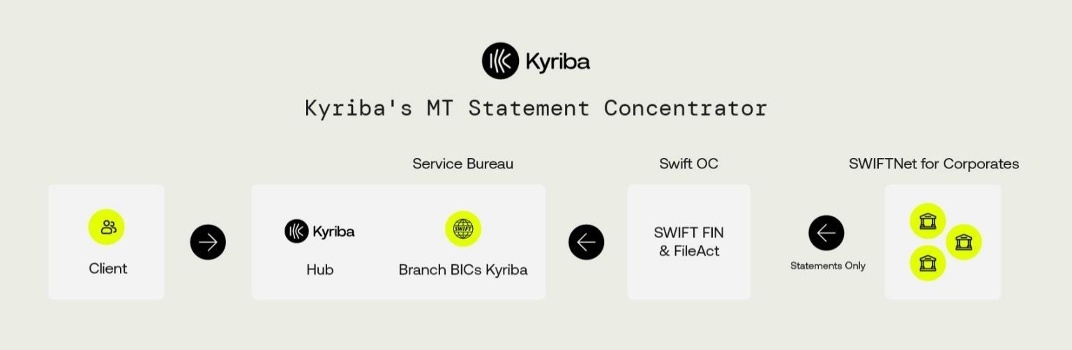
Applicable functions include embedded SWIFTNet channel for statements.

- Market Data (Standard)
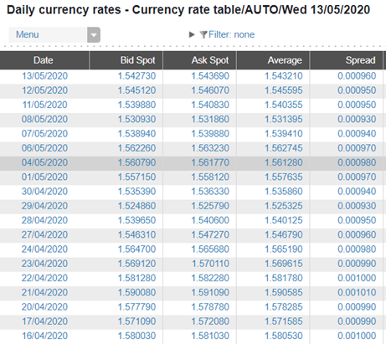
Kyriba is delivered with its own market data engine, allowing rates, curves and prices to be delivered and integrated without any further action from any customer. Kyriba’s market data service includes FX spot rates and interest rate fixing. 500+ currency pairs and 3,000 data points are currently included in this service.
Sources of data include market-related static data such as currencies and rates.
Applicable functions include market data point definition and reporting for the following types:
- FX spot (multiple fixing markets): 550 spot rates currently available
- Money Market indices: 170 indices
currently available

- Market Data export

As part of Kyriba’s market data service, FX spot and Interest Rate Fixings can be exported to third-party systems, notably ERPs and accounting systems. Kyriba’s Data Exchange engine can format the export file or message to comply with the destination solution. Kyriba’s market data service includes FX spot rates and interest rate fixing. 1,250 end-of-day and intra-day market rates and 3,600 Central Bank rates are currently included in this service.
Sources of data include market-related static data such as currencies and rates.
Applicable functions include market data point definition and export for the following types:
- FX spot (multiple fixing markets and timing): 4,000+ rates currently available
- Money Market fixings: 200 indices
currently available

- Blackrock Money Market Connector
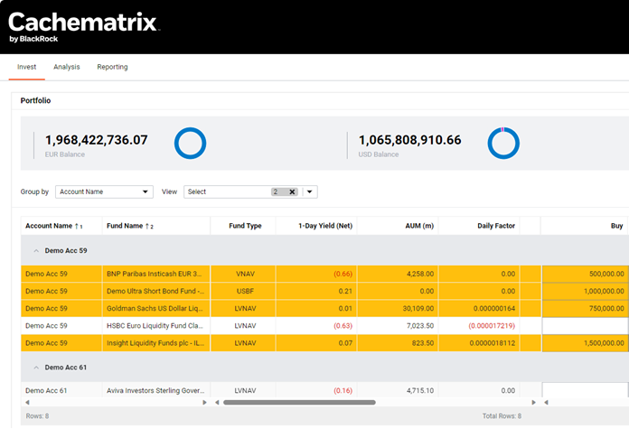
Kyriba partnership with Blackrock means faster and smarter execution of cash investments for CFOs and corporate treasurers. Users of this module can seamlessly allocate cash to a variety of money market funds through BlackRock’s integrated trading platform (cachematrix) and through its 28 Multi-Fund Partners (and growing).
The Blackrock integration allows for single sign-on to the trading platform, access to research, cross-fund portfolio reporting and self-directed trading within cachematrix, before seamless import into Kyriba. The Investment Position Keeping further records the orders executed in cachematrix as MM variable balance funds for further trade processing (including settlement and accounting).
Sources of data include imported variable balance financial transactions only.
Applicable functions include bilateral Kyriba-cachematrix user identification and security, transport of transaction request and orders between platforms, Investment trade bulk modification and enrichment; forecast and settlement generation (where applicable), accrual, maturity process; portfolio and deal-based reporting in nominal
value (not MTM).

- ICD Money Market Integration
ICD and Kyriba have deeply integrated their market-leading technologies for a fully automated, API end-to-end workflow. From single sign-on access to end-of-day sweeps, managing cash and ICD-executed investments in Kyriba becomes seamless.
The ICD Money Market integration allows for single sign-on to the trading platform, access to research, cross-fund portfolio reporting, execution of Kyriba-suggested cash sweeps and direct trading. Executed orders are seamlessly imported into Kyriba as MM variable balance funds, for further trade processing.
Sources of data include cash imported variable balance transactions only.
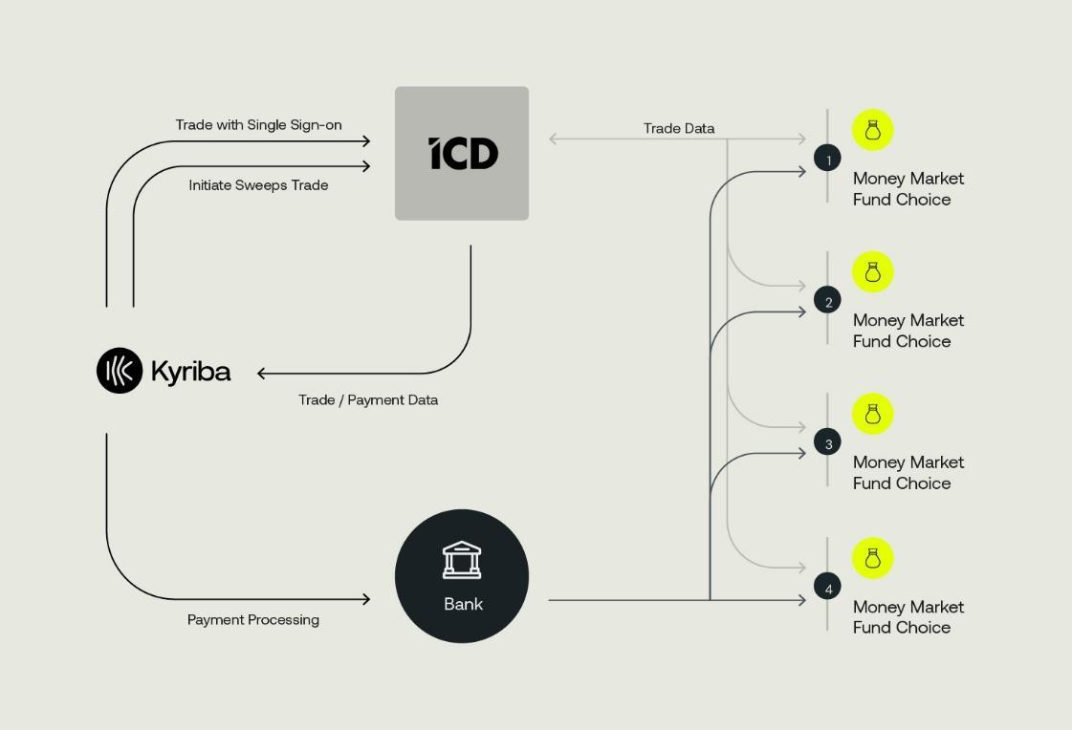
Applicable functions include bilateral Kyriba-ICD user identification and security, transport of transaction request between platforms, Investment trade bulk modification and enrichment; forecast and settlement generation (where applicable), accrual, maturity process; portfolio and deal-based reporting in nominal value (not MTM).

- Goldman Sachs Mosaic Integration
Goldman Sachs and Kyriba collaboration provides connectivity with the Mosaic investment portal, for trading, reporting and analytics on Goldman Sachs-provided money market funds.
The Goldman Sachs Mosaic Integration allows Kyriba-suggested trade requests to be executed in the Mosaic investment portal, streamlining subscription and redemption requests. The integration to GS Mosaic allows for real-time workflows around balances, confirmations, fund prices, and daily factors, eliminating the need for manual data entry. The integration is granted through Single Sign-On, for seamless navigation between platforms. Goldman Sachs Mosaic provides access to the rich set of money funds liquidity analytics, and reporting. Executed orders are seamlessly imported into Kyriba as MM variable balance funds, for further trade processing. Sources of data include imported variable balance financial transactions only.
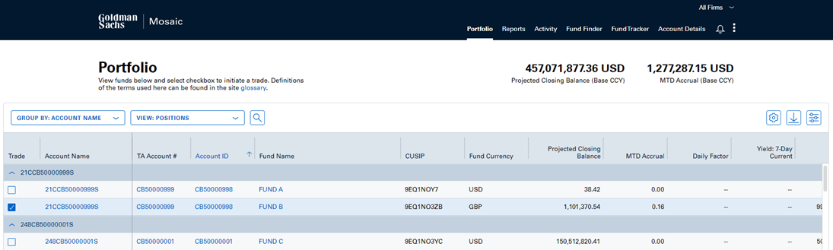
Applicable functions include bilateral Kyriba-Mosaic user identification and security, transport of transaction request and orders between platforms, Investment trade bulk modification and enrichment; forecast and settlement generation (where applicable), accrual, maturity process; portfolio and deal-based reporting in nominal value (not MTM).


- Trusted AI (TAI)
What is TAI?

TAI (Trusted Agentic AI) is Kyriba's embedded agentic AI that helps treasury teams find answers faster, validate data with confidence, and move work forward—without building templates or leaving their workflow. Unlike simple chatbots, TAI plans and executes governed, multi-step treasury workflows on trusted Kyriba data—with explainability, role-based controls, and full auditability.

TAI is an agentic AI because it will plan and execute governed, multi-step treasury workflows on trusted Kyriba data—with explainability, role-based controls, and full auditability—rather than merely an AI chatbot responding to prompts.

Why "Trusted" AI?

TAI is hosted by Kyriba within Kyriba's AWS
environment, so AI computations run under the same high security, governance, and compliance controls that protect all Kyriba data, without sharing with public AI services. Every answer is transparent by design: TAI shows its reasoning, including the steps taken, reports executed, and data sources referenced, so you can verify how results were produced.

TAI is part of Kyriba's Trusted AI portfolio (which also includes Cash AI, Invoice AI, and Fraud Detection AI) and provides:

• Faster insights
• Fewer manual steps
• Improved forecast accuracy
• Accelerated user onboarding

Optimized Workflows Example:
Without TAI: Multiple steps to access reports, navigate dashboards, and extract data (time varies by user)
With TAI: Ask "What are my bank balances today in the US?" (~5 seconds)

TAI AGENTS

TAI currently includes two specialized agents:

1. @treasury analyst agent
- Run treasury actions and workflows
- Produce reporting and analysis
- Reduce time investigating breaks and reconciliations

2. @help agent
- 24x7 support using semantic search of Kyriba Online Help
- Accelerate onboarding for new users
- Reduce questions to Kyriba support and internal experts

KEY CAPABILITIES

DISCOVER
• Universal access: Engage TAI anywhere in Kyriba using plain language
• Live information: Ask for balances, payment statuses, and bank statements—no downloads required
• System awareness: Ask TAI what reports and connections it can currently see in your environment
• Agent framework: Access specialized agents for specific tasks

ANALYZE
• Transparent results: Review the steps and sources TAI used for each answer
• Cash reconciliation: See reconciliation rates, spot unreconciled/on-hold transactions, and understand impact on cash
• Variance insights: Surface Proof of Cash variances and identify critical vs. minor issues with suggested next steps
• Forecast variance: Compare forecasts to actuals over custom periods (day-over-day, week-over-week) and spotlight key drivers

ACT
• Report automation: Have TAI run specific Kyriba reports (e.g., Bank Connectivity Cockpit) to confirm expected statements and data completeness
• Payment visibility: Show payments pending approval with amounts, recipients, and approval levels—aligned to your permissions and naming
• Guided reconciliation: Identify on-hold transactions, compare with forecasted items, and follow TAI's guidance to the right Kyriba tools or connected services

SHARE
• Export ready: Download results to Excel or CSV directly from TAI
• Visuals on demand: Generate charts (e.g., original vs. current forecasts across entities) and download images or underlying data

GET HELP
• TAI Help: Use the help button for answers from the Kyriba Online Help portal with semantic search—quick guidance without leaving your workflow
• Cross-check any number: If you're unsure about a figure, ask TAI to compare its result with any available Kyriba report or to rerun the underlying report and reconcile differences. TAI will show its reasoning and references so you can validate the source

KYRIBA UNITS EXPLAINED

What Are Kyriba Units?

Kyriba Units are the consumption-based metric for TAI usage. Each interaction with TAI consumes units based on the complexity of the request.

Unit Consumption by Interaction Type:

INTERACTION TYPE | UNIT RANGE | EXAMPLES

Simple Query | 1-2 units | "What's my current global cash position?", "Show me today's bank balances across all entities", "List all our active bank accounts in Germany", "How to create a user in Kyriba?"

Simple Interaction | 3-5 units | "Show me next week's cash forecast" → "What are the main drivers of the variance?", "What's our Q3 liquidity projection?" → "How does this compare to last quarter?", "Display cash flow by entity" → "Which entity has the highest outflow?"

Complex Interaction | 6-10 units | "Analyze our global cash position", "Identify surplus cash by region", "Recommend optimal investment opportunities", "Prepare investment proposal for CFO review"

Note: Query returns and unit consumption will vary by customer based on data complexity and environment configuration.

- Payments
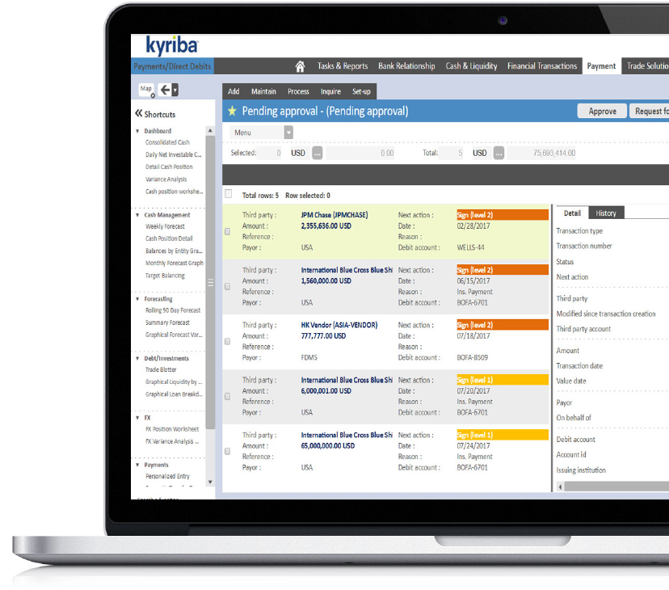
Kyriba is a multi-channel global payments solution to support treasury, shared services and finance teams for bank and non-bank payment types. Kyriba’s payment factory offers pre-built bank formats and embedded bank connectivity for secure, straight through processing of A/P payments to global banks.
Kyriba executes Accounts Payable transactional activity, fully manages bank connectivity and delivers superior fraud detection and visibility to de-risk ERP payment projects. Urgent and non-urgent payments can also be initiated within Kyriba as free-form by template, via import from ERP, or through integration with other platform capabilities such as Netting, Financial Transactions or Trade Solutions. Kyriba Payments digitizes payment workflows, standardizing payment controls to comply with internal payment policies, approval procedures and limits so that only authorized payments are executed.
Answering to the compliance drive of our customers, Kyriba's real-time fraud detection screens payments against government sanction lists, corporate payment policies and historical data patterns to automatically quarantine suspicious and non-compliant payments for threat assessment. Payment approval reminders can be automatically emailed and approvals can be made from any browser or through an iPad or iPhone, via the Kyriba mobile app.
In order to reach more than 500 banking groups, bank connectivity options include SWIFTNet through Alliance Lite2 and Kyriba’s embedded SWIFT Service Bureau+, APIs, FTP, EBICS, BACS, Editran, CBI, Zengin and other
regional protocols.
Kyriba offers a global, multi-bank payments hub solution to drive integration, standardization, consistency of controls and payment execution security across the enterprise. Kyriba Payments accelerates ERP payments and bank connectivity projects, eliminating project risk and drastically reducing connectivity costs.

Payment Management
- Payments [also in Kyriba for Mid-Market]
In Kyriba’s standard Payments module, instructions to pay or debit can originate via manual request entry by local user or repetitive templates from financial transactions. Authorisation panels can be defined to control the nature and amount of the payments that an individual working alone or with others can authorise.
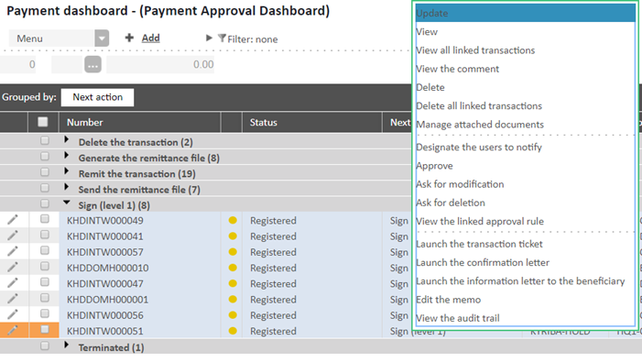
Kyriba homogenizes the various bank payment output formats, into a single standardized format on the screen for validation, signature and export.
Sources of data include manually captured payment orders, financial transactions (where applicable).
Applicable functions include payment capture template setup, authorisation panels setup, dual-factor signature token enablement per user, approver reminder template setup, payment batch creation, payment runs definition, payment release rules definition, payment release process, acknowledgement import, dashboard reporting, pending payment reporting, payment order reporting.

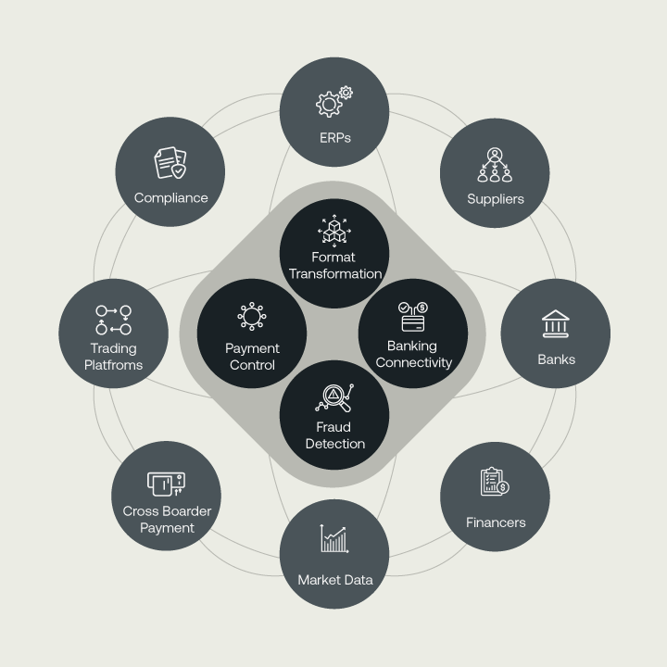
- Payment Factory [also in Kyriba for Mid-Market]
External payment files can be imported in Kyriba as batches or individual payments into Kyriba for individual approval, bulking then release in generation mode. Preapproved payment files can also be imported into Kyriba as batches or files, and then released in routing mode via any available connectivity option.
Payment Factoring in Kyriba delivers financial value to Treasuries through transfer and transmission cost optimisation and straight-through forecast, as well as operational efficiencies through managed formatting and Bureau services. Mobile approval and signature contributes to safely and efficiently free Treasuries from their desk.
Sources of data include imported payment files or batches, manually captured payment orders, financial transactions (where applicable).
Applicable functions include above-mentioned as well as payment files, batches and orders import in blind/intelligent routing or integration.

- Direct Debit [also in Kyriba for Mid-Market]
Kyriba supports direct debit execution, leveraging the Kyriba Global Connectivity Hub. Direct debits can be used for cash pooling purposes or as a receivables collection engine. Direct Debit management in Kyriba includes mandate assignment (see next section), processing of DD orders as well as their bank acknowledgements including all R transaction types for SEPA (Reject, Refusal, Return, Refund).
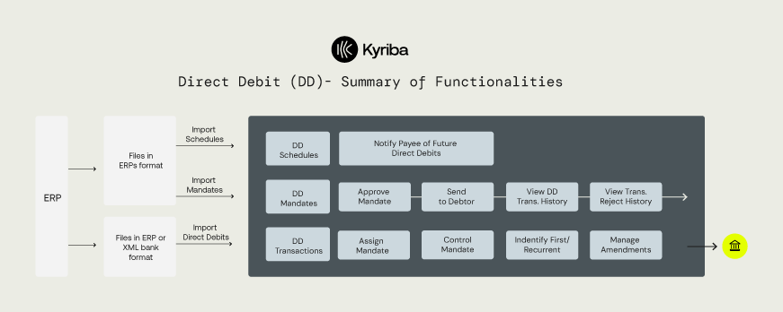
Sources of data include imported Direct Debit
order files and batches, manually captured Direct Debit orders and generated DD from SEPA
mandates processing.
Applicable functions include Direct Debit capture template setup, authorisation panels setup, dual-factor signature token enablement per user, approver reminder template setup, Direct Debit batch creation, Direct Debit runs definition, Direct Debit release rules definition, Direct Debit release process, acknowledgement import (including R transactions), dashboard reporting, pending Direct Debit reporting, Direct Debit order reporting.

- SEPA Mandates [also in Kyriba for Mid-Market]
Kyriba is SEPA-compliant, allowing mandates to be electronically signed by the payer, to authorize the biller to collect a payment and to instruct the payer’s bank to pay the agreed collections.
Mandate documentation is securely stored and accessed for verification. Kyriba supports the regulated expiration of mandates which blocks the direct debit from being initiated in the payment
management workflow.
Sources of data include imported Direct Debit mandate files and manually captured Direct Debit mandates.
Applicable functions include DD mandate creation, DD schedule definition, Reports of Rejected Mandates and Schedules, Mandates export,
Import of Mandates, Import of DD Schedules and Mandate categorisation.

- Netting
Kyriba’s multilateral invoice netting module provides tools for the collation of internal netting flows via file import or remote invoice submission. With a netting cycle in accordance with each customer’s accounting calendar, the invoice cycle is driven by inter-company payable or receivable items that can be settled across In-house or external bank accounts as appropriate.
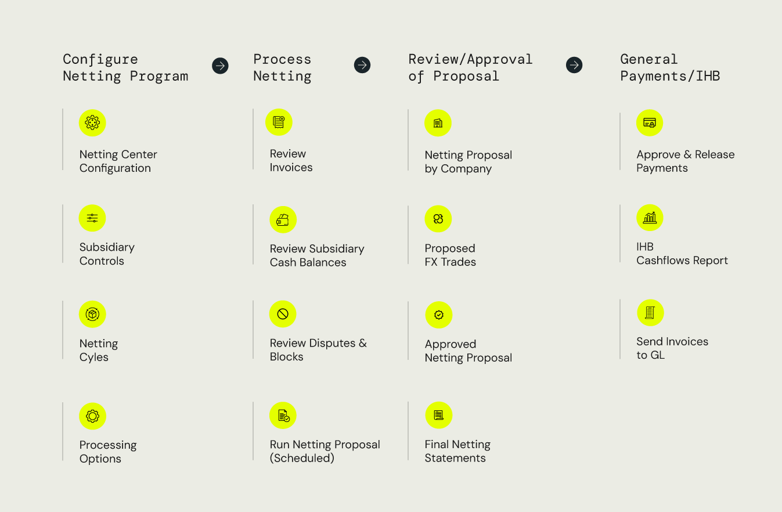
Kyriba's multilateral netting also includes dispute management, with a dispute being raised by a valid participant in the form of structured reason and free commentary. Treasury has the ability to block the invoice until dispute is resolved and reintegrated into the current or following netting cycle. Sources of data include imported netting invoices only.
Applicable functions include cycle definition, approval and run; netting invoice import; dispute recording and reporting; leads and lags management; netted settlements and actuals cashflows creation; FX exposure reporting; invoice, settlement and forecast reporting.

- Draft Payables
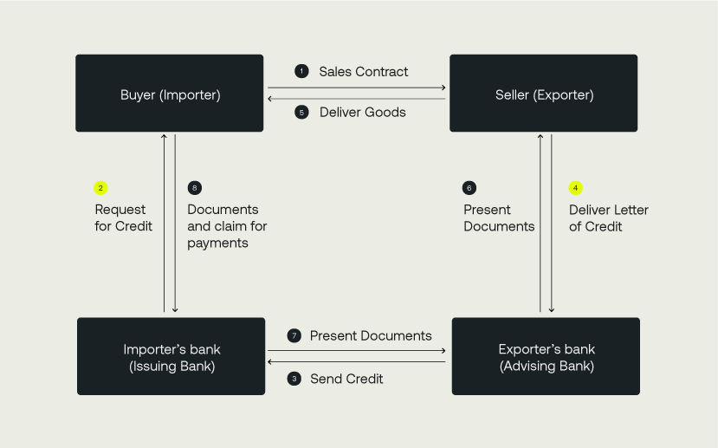
A payable draft is a Bank-guaranteed trade finance guarantee, which forces a debtor company to pay its supplier invoices electronically at expiry or prior. It is a commercial instrument used for short-term liquidity management raised by the creditor / supplier, owing to which the creditor declares its entitlement (with supporting documents) to receive from the debtor / client a sum of money to be paid to the creditor bank to complete the payment of one or multiple invoices. From a debtor’s perspective, this allows the creditor's bank to collect the amount indicated, minus a discount margin defined by the creditor’s bank as a flat amount or rate.
It has different legal forms and names, according to the country: "billet à ordre" (BOR) and "lettre de change relevé" (LCR) in France, "ricevuta bancaria" (RI.BA or Riba) in Italy, "Confirming" in Spain, "documentary credits" and “bills of exchange” in UK and US. Kyriba manages draft payable workflow of message acknowledgement, approval and bank communication process for countries where draft payables are supported.
Sources of data include imported Payable drafts, manually captured Payable drafts.
Applicable functions include Payable draft capture and import, Draft bank statements management (in local format), automated reconciliation draft vs statement, Payables drafts export, audit report of all discounted drafts, statement of all drafts accepted for discount and accounting reporting of drafts.

- Draft Receivables
A receivable draft is a Bank-guaranteed trade finance guarantee, which allows a creditor company to collect its client invoices via local bank branches. It is a commercial instrument used for short-term liquidity management, owing to which the creditor declares its entitlement (with supporting documents) to receive from the debtor / client a sum of money paid to the bank to complete the payment of one or multiple invoices, thus authorizing the creditor's bank to collect the amount indicated, minus a discount margin defined by the creditor’s bank as a flat amount or rate.
It has different legal forms and names, according to the country: "billet à ordre" (BOR) and "lettre de change relevé" (LCR) in France, "ricevuta bancaria" (RI.BA or Riba) in Italy, "Confirming" in Spain, "documentary credits" and “bills of exchange” in UK and US.
Kyriba manages draft receivable workflow of message acknowledgement, approval and bank communication process for countries where draft receivables are supported.
Sources of data include imported Receivable drafts, manually captured Receivable drafts.
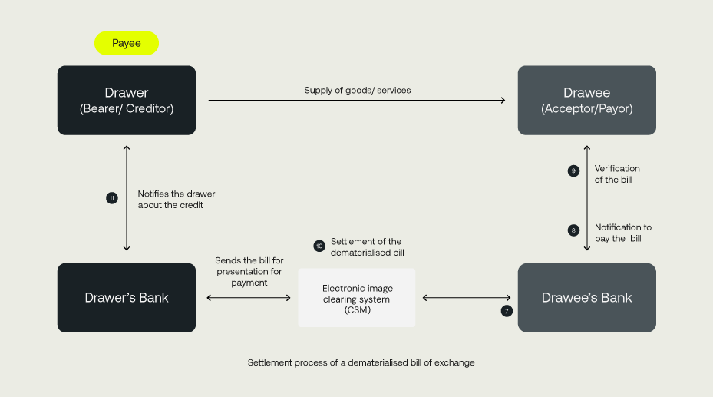
Applicable functions include Receivable draft capture and import, Remittance management, Receivable Draft remittance export, Receivable Draft discount statement and accounting reporting of receivable drafts

- Payment Builder
Kyriba’s Payment Builder allows for imported individual invoice documents to be offset and bulked into consistent payment orders. It ultimately targets transfer cost reduction by producing a single payment instruction and remittance for a batch of invoices.
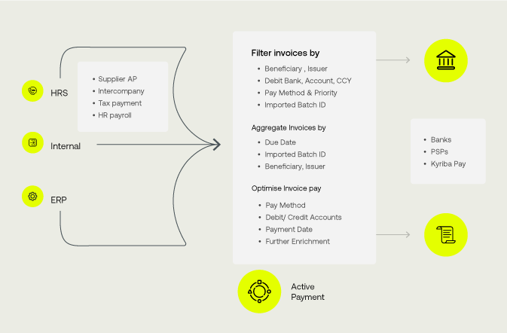
Sources of data include imported invoices only. Applicable functions include consolidation and netting of invoices, creation of payment transactions.
Fraud Management
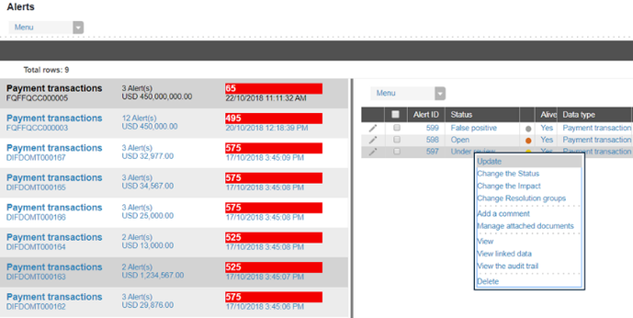
- Fraud Detection
Kyriba’s Fraud Detection module allows for ad-hoc rules (based on standard templates) to be set up in order to analyse payment patterns, highlight, isolate and eventually block inconsistent payment instructions. Those patterns can relate to approver or inputter users, as well as individual transactions (imported as is or as part of a file), history of transactions and user activity. Kyriba’s alert centre allows for fraudulent cases to be isolated and dealt with by the relevant compliance group. The fraud detection module also includes a Machine Learning to apply past learnt advanced patterns to current potential fraud cases.
Fraud detection can be applied to routed files under the following context:
- Blind Routing: no Fraud detection is applied;
- Intelligent Routing: Kyriba Fraud detection engine parses several key file fields, for 100 formats or so: fraud incidents forbid the entire file to be released;
- Fast Track: Kyriba fraud detection parses many file fields, applied to ISO 20022 only: fraudulent transactions are excluded from the file release.
Sources of data include imported routed payment files, generated, imported or captured individual payment instructions.
Applicable functions include fraud detection exception reporting, KPI and alert dashboards.

- Fraud Screen data volume
This option stands for the number of payment orders analysed by Kyriba’s Fraud Detection engine on a monthly basis. All individual payment instructions as well as all lines of all payment files submitted to the Fraud Detection engine are included in this monthly counter.
Sources of data include imported routed payment files, generated, imported or captured individual payment instructions captured by the rules of the Fraud Detection module.

- Payment Screening
Kyriba is embedded with a global payments sanctions screening service that flags potential issues with payments to vendors to limit delays and provide early detection on potentially risky payments. All payments generated by or routed through Kyriba can be pre-screened. Users are notified (in the application and/or email) inside Kyriba of potential compliance issues before payments are effectively sent to the bank. LexisNexis Fircosoft payment screening is embedded in Kyriba with optimized OFAC, UN and EU sanction lists as default; further lists can be subscribed to on demand and included in the workflow.
By proactively pre-screening payments as part of a standard workflow, Kyriba enables its client companies to avoid (or better prepare for) deceleration in their payment execution.
Sources of data include imported subscribed screening lists, routed payment files and individual payment instructions. The module requires the Fraud Detection’s alert centre (see below) for fraud
case reporting.
Applicable functions include screening exception reporting, warning email; setup of the banks and payment types to include in screening. The fraud case output from the sanction screening process are displayed in the Fraud Detection alert and
KPI dashboards.

- Payment Anomaly detection using Machine Learning
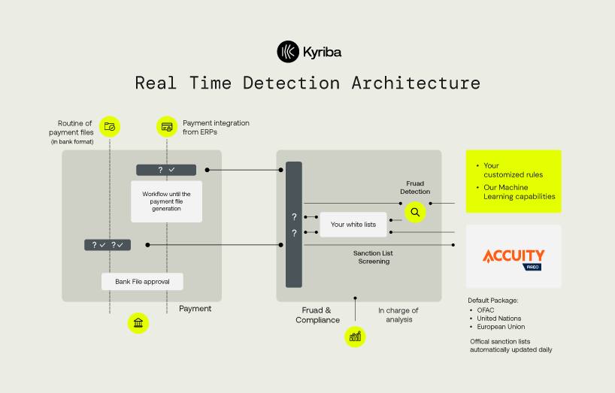
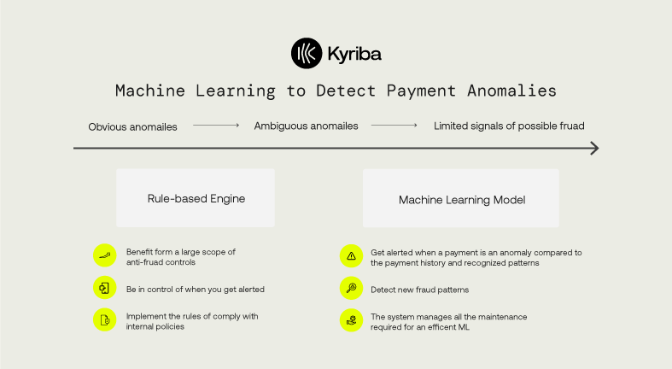
Payment anomaly detection using Machine Learning allows to identify payments that are abnormal according to its payment history. In order to achieve that, Kyriba leverages Machine Learning, an innovative and powerful technology. A payment is considered as an anomaly if the combination of attributes is rare in the payment history, this does not necessarily mean the payment is a fraud
Sources of data include imported routed payment files, generated, imported or captured individual payment instructions captured by the rules of the Fraud Detection module. The main “Fraud Detection” module is required for this function to be activated. Kyriba’s BI for Payment is required for the ML data sets to be stored and leveraged.
Applicable functions include fraud detection exception reporting, KPI and alert dashboards.
- Bank Account Validation
Using application programming interfaces (APIs), Kyriba connects, in real-time, to cloud-managed databases and confirms that the bank accounts being credited to in the payment instructions belong to the intended counterparty. This is one important layer of protection in the fight against Business
Email Compromise (“BEC”) scams and other
phishing attempts.
Kyriba has partnered with specialists offering robust, scalable platforms for real-time authentication of bank data from third parties, customers and suppliers, complementary to one another in all regions reached by Kyriba's users. The overall Bank Account Validation solution is integrated into Kyriba's payment and fraud solutions, making it a simple point of control for users.
Applicable functions include validation and verification of third-party data, during the import
or submission of payment, within Kyriba's
payment workflow.

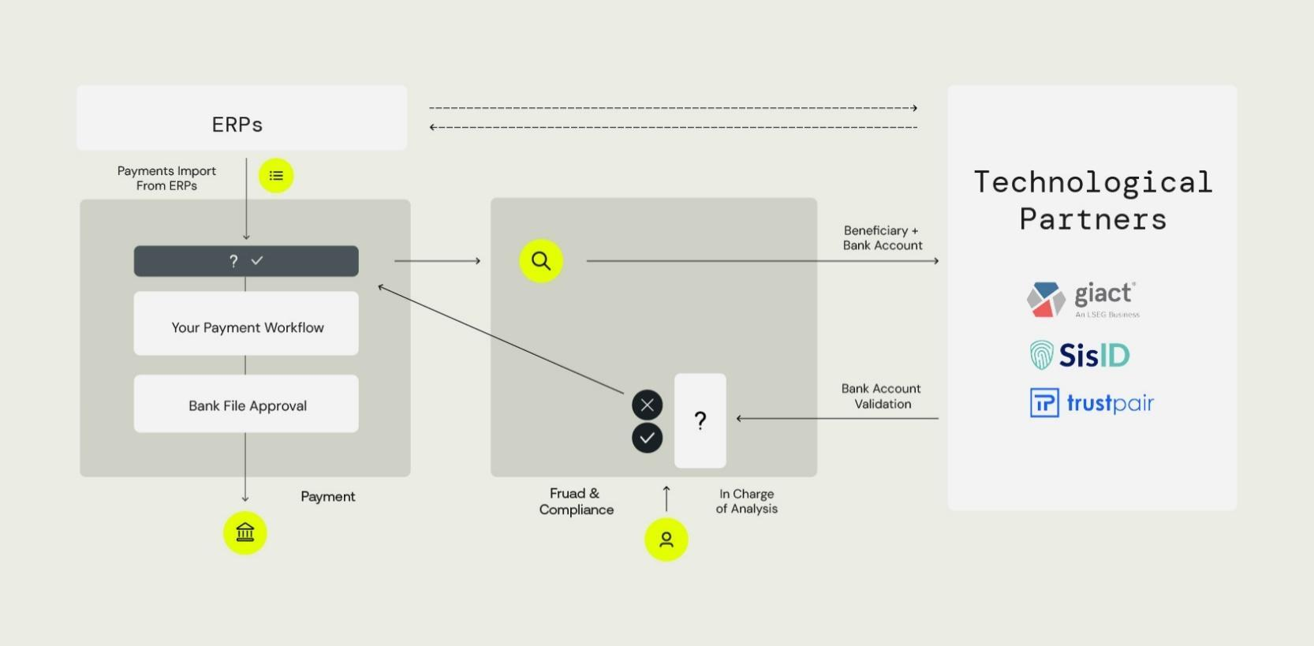

Data and Analytics for Payment, Fraud and Compliance
- Payment Analytics
Kyriba's BI tool enables users to effectively analyse and optimise their strategic decision-making by delivering actionable insights and capabilities that unlocks value within the Kyriba treasury-related data. It elevates communication and strategic value, by increasing shareable insights, transforming data into information and reducing the time to research information in several locations.

Payment Analytics is a customer-specific data warehouse with a business-orientated data model dedicated to analysis. It stores historical over years and decades. Its embedded reporting is composed of cross-domain tables, views, measures and ready-made Key Performance Indicators. It also delivers cross-domain customer-definable views, drag-and-drop abilities, advanced formulae, best-of-breed graphics, report package design and fully interactive dashboards.
Sources of data include data from the Payment and static data modules.
Applicable functions include five (5) off-the-shelf views:
- Overview
- What are my payment transfers? (including originating countries, beneficiary countries, senders and beneficiaries)
- Do I have manual payments? (including trends, origins, link to budgets, sender sources)

- Who generates payments? (including users, trends, signatories)
- What are the details of my payments? (including a payment pivot table with on-screen filters).
Licensed Payment BI users have access to all 5 standard views in read-only mode and other personalised views in read-and-write mode.

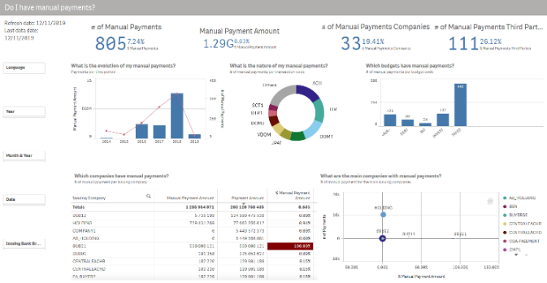
Licensed Payment BI users have access to all 5 standard views in read-only mode and other personalised views in read-and-write mode.
- Compliance Analytics
Kyriba's Compliance Analytics is a Business Intelligence app available focused on user, rights, data and token administration within Kyriba.
Sources of data include Users, Access Profiles, Modules, Data Permissions and user tokens.
Applicable functions include seven (7)
off-the-shelf views:
- Who are my users? (including active vs inactive, administrator rights, geography)
- What are my main user groups? (including active groups breakdown)
- How are tokens assigned to users? (including active vs inactive, administrator
rights, geography)
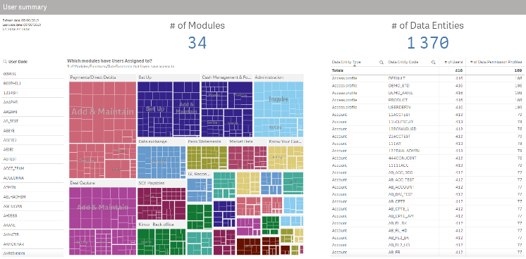
- Which modules can my users access? (including access profiles breakdown)
- Which data can my users access? (including data profiles breakdown)
- How are data permissions built? (including detailed data accesses and analysis)
- User summary (including statistics of menu access per module with data profiles)
Licensed Analytics users have access to all 7 standard views in read-only mode and other personalised views in read-and-write mode.

Other notable options
- Control Center
Kyriba's interface control centre fully audits all interface actions, including all error events, process failures and repair actions performed, so that the user enjoys full transparency and control over the Kyriba side of bank communications.
It is possible to see in standard reports whether a bank statement (even on SWIFT network) has failed to upload or if an expected number of statement files has not yet been fully integrated.
Sources of data include imported and exported files of any kind managed by the application.
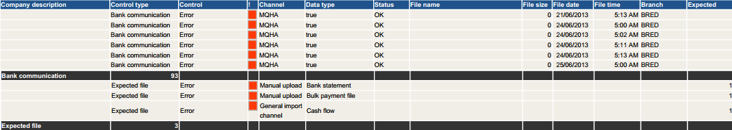
Applicable functions include expected file check definition; advanced reporting. This function is notably applicable to imported payment files (in integrated line-by-line mode) and exported remittances for instant on-screen and email automated control reports. Licensed Control Center users have access to the file check setup, the definition of and the run access to those reports.

- SWIFT Bank Directory Plus
Business Identifier Codes (BIC, formerly Bank Identifier Codes) are essential to the correct execution of any payment over the SWIFT Network. BICs are used along the whole chain of payment from the corporate payment issuer, to the debiting or credited banks via all eventual correspondents in between. SWIFT manages a central BIC Directory and proposes its access directly or via financial solutions like Kyriba. Kyriba’s SWIFT Bank Directory Plus contains all accurate and up-to-date bank BIC data to prepare, validate and process payments to any bank over SWIFT, anywhere and at any time.
It includes all BIC codes, sources directly from the ISO 9362 Registry as well as Names and addresses of banks in their local language. Kyriba thus allows to
- Automatically search and apply the Bank Directory BICs on existing Banks in bulk
- Manually access the Bank Directory on a bank branch, a beneficiary, or a correspondent bank and apply changes to BIC and address
- Check BICs correctness against the Bank Directory during payment file import and release
Sources of data include embedded connection to SWIFT-managed BIC directories, individual payment instructions and bank static data.
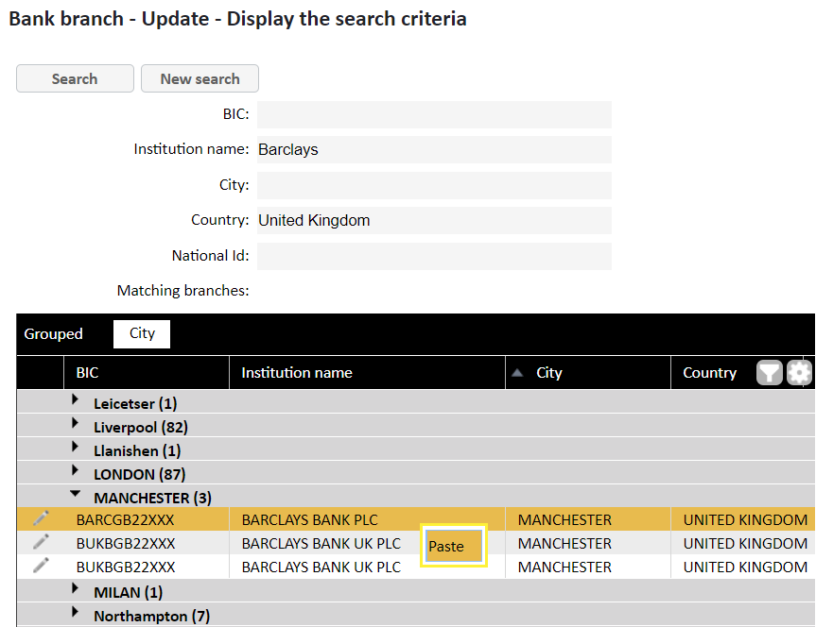
Applicable functions include Third party static data import and manual BIC controls, Payment data BIC control at import and at release.

- Bank Payments - Concentrator [also in Kyriba for Mid-Market]
Kyriba’s Payment Concentrator service stands for the release of urgent payments in MT101 format through an independent BIC on the SWIFTNet for Banks network. It is applicable only to same-day / High-Value Domestic & Cross Border payments via a SWIFT Service Bureau+ partner of Kyriba.
With this option, our customers do not require to become a SWIFTNET for Corporates member and obtain their own BIC. Its cost is calculated per account.

- Payment: Digital Signature [also in Kyriba for Mid-Market]

Electronic digital signature (such as 3SKey on all networks, not limited to ebics and SWIFTNet) can be used in Kyriba as a dual-factor authentication (2FA) token for payment approval, and one or multiple included in the overall workflow.
Sources of data include imported payment files or batches, manually captured payment orders, financial transactions’ payment instructions (where applicable). Applicable functions include token session setup per user; on-screen certification and check. Licensed Digital Signature users have access to the digital payment certificate entry screen.

- Multi-Factor Authentication [also in Kyriba for Mid-Market]
Multi-Factor Authentication (“MFA”) with Yubikey, SWIFT 3SKey or X509 certification compliant device, user-specific certificate and one-time password via SMS (and backup) are advanced security functionalities in Kyriba, notably for payment signatories. Kyriba Multi-Factor Authentication helps protect user accounts from unauthorized access to Kyriba if someone has managed to steal your password. When multi-factor authentication is activated, the user is prompted to enter the one-time password after submitting their normal user ID and password.
Multi-Factor Authentication is an optional procedure and includes:
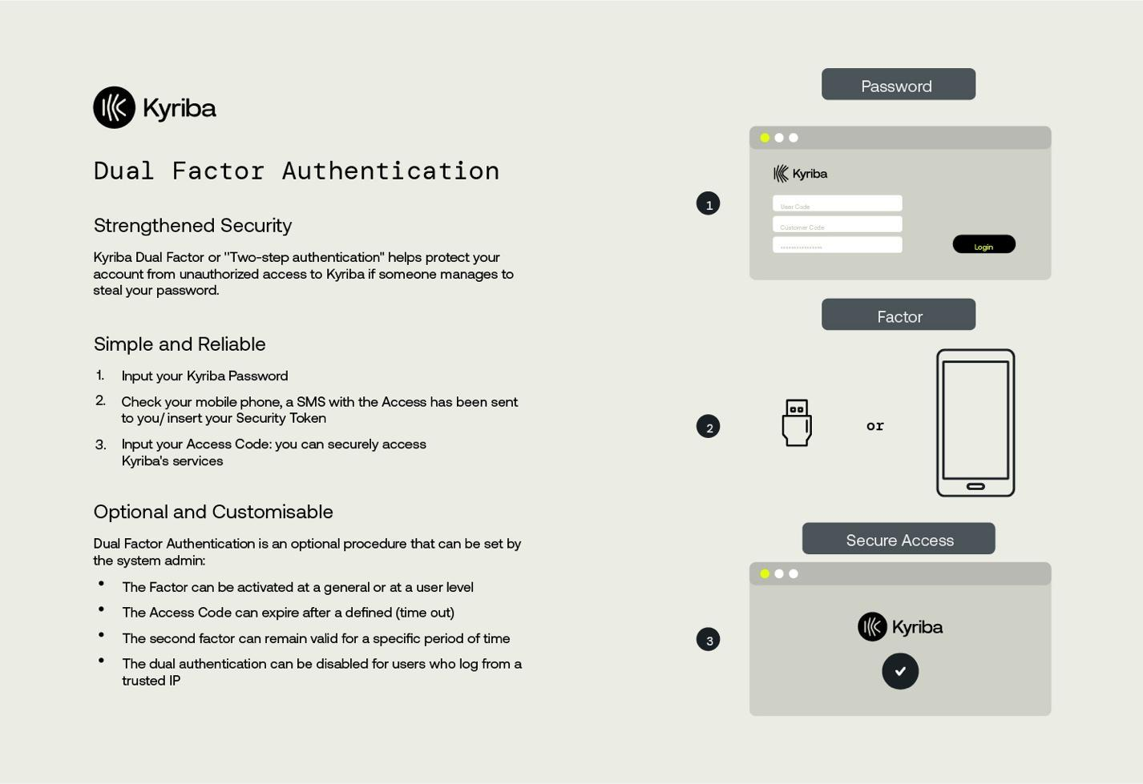
- An activation at general or user level
- User Access Codes can expire after a defined session timeout period
- The second factor can also remain valid for a specific period of time
- MFA can be disabled for users who log from a trusted IP.
Multi-Factor Authentication has however become a requirement for all users activated within Kyriba’s Payment module when using a SWIFT Alliance Lite 2 or Service Bureau connection.
Sources of data include user MFA setup only.
Applicable functions include user certification
at logon.
Licensed MFA users have access to the digital logon certificate entry screen.
- Risk Management
Kyriba’s Risk Management offers exposure management, FX and Interest Rate Hedge recording, valuations, risk analysis, derivative and hedge accounting, as well as lease accounting, with full integration to balance sheet and income accounts within General Ledger systems.
Kyriba’s Financial Transactions supports the tracking and management of debt, foreign exchange, interest rate and investment transactions through a centralized dashboard available to the treasury team and other departments. All of the modules are seamlessly integrated supporting straight-through-processing (STP) across cash forecasting, payments, in-house banking, and accounting. Kyriba can compute the independent market value of all financial instruments tracked in the platform. Valuations are calculated based on Kyriba’s Market Data Service (included with the system) or from externally sourced data. Kyriba supports modification of currency and interest rate curves so that users can analyse the sensitivity of different FX and interest rate projections. Value-at-Risk analysis is also available across all asset classes for deeper understanding of the market risk impact on the customer's financial portfolio.
Kyriba’s flexible reporting capabilities allow users to generate reports on any of the financial transaction data including payment or maturity schedules, position reports, mark-to-market, accruals, interest statements, fees, gain/loss, etc.
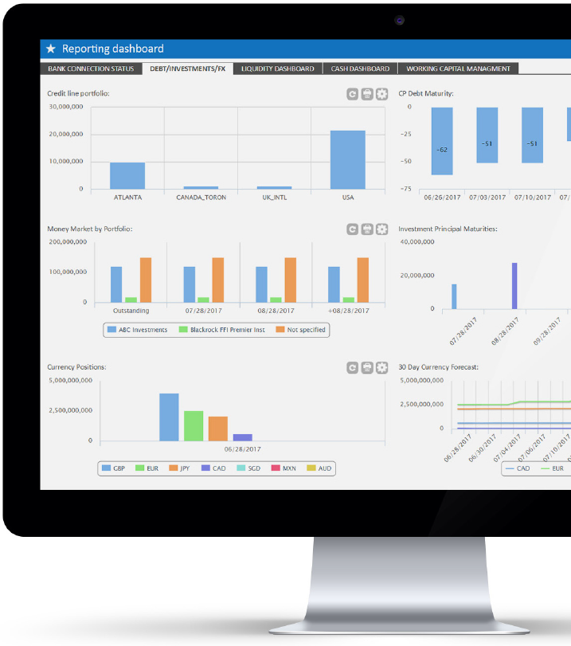
Kyriba delivers advanced capabilities for managing the entire lifecycle of FX, Interest Rate and Credit risk. Embedded market data and trade portal integration enable complete workflows to support hedging programs and regulatory compliance. Using Kyriba, clients achieve better visibility into risk
exposures and make more effective risk management decisions.

Risk Management and Financial Transactions
- Position Keeping [also in Kyriba for Mid-Market]
Kyriba offers a centralized dashboard of treasury activity, including all financial transactions managed by the treasury team. Through Kyriba’s web portal, users have complete visibility into Investing, Borrowing, Trading, and Hedging activities.
It provides them with the productivity tools to improve the efficiency of deal tracking, portfolio management, settlements, accounting, and reporting. Kyriba’s suite of Financial Transaction modules includes:
  - Debt: Short Term Loan, Certificates of Deposit, Commercial Paper, Notes, Trade Bills, Funds Transfers, Credit Line; Fixed Rate Loans, Floating Rate Loans, Fixed Rate Leases, Floating Rate Leases
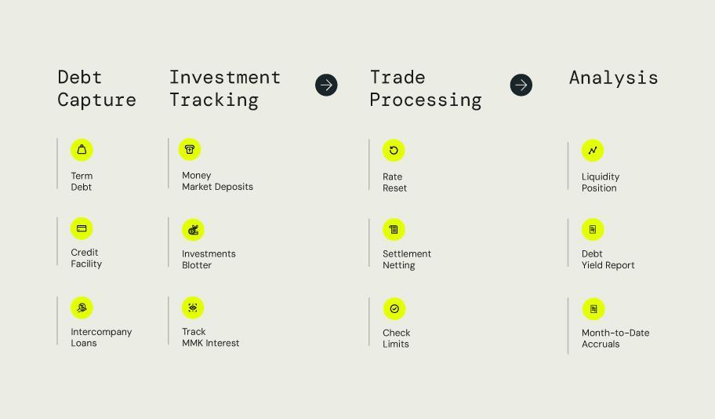
  - Foreign Exchange: Spots, Forwards, Swaps, Plain-Vanilla Options, Barrier Options, FX Exposure;
  - Investments: Short Term Deposits, Fixed Rate Deposits, Floating Rate Deposits; Mutual Funds and MM variable balance funds, Certificates of Deposit, Commercial Paper, Notes, Trade Bills, Funds Transfers;
  - Interest Rate Derivatives: Interest Rate Swaps, Cross-Currency Swaps, Knock-In/Out IRS, Caps, Floors, Collars.
  - Commodities Derivatives: spot, forward, forward strips, and swap.
Sources of data include imported or captured financial transactions only.
Applicable functions include bulk modification and enrichment; forecast and settlement generation (where applicable), accrual, amortisation and maturity processes, trade confirmation creation; portfolio and deal-based reporting in nominal value (not marked to market).

- EMIR Reporting
Kyriba can export a Trade Repository-agnostic EMIR report using its "Extract, transform, load" (ETL) tools. Kyriba's ETL engine is based on mapping table and user-definition in simple screens of the expected input or output format (including dates, separator, etc.). Kyriba's EMIR reporting includes number of required indicators, aggregated and reported each day and sent automatically to the customer’s Trade Repository of choice via secure FTP channel or in-folder file drop.
Sources of data include approved FX and Interest Rate Derivatives financial transactions, whether internal
or external.
Applicable functions include EMIR report file creation, creation logs.
Licensed Position-Keeping users have access to EMIR report file creation, the definition of and the run access to EMIR reports.

- Valuation
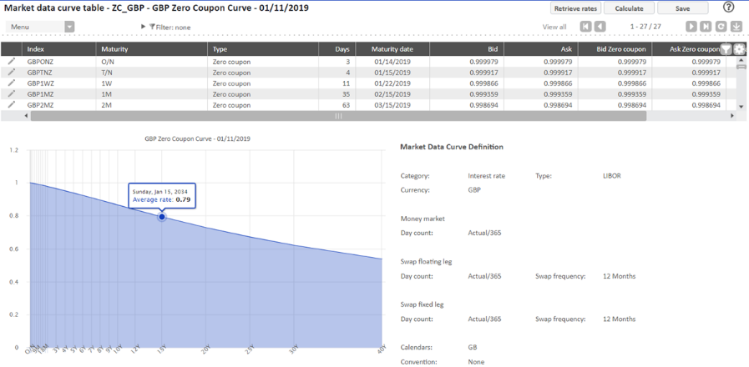
Kyriba includes powerful simulation and optimization risk management tools. A combination of Kyriba Worksheets, Blotters and Reports (depending on the final output required) is available out of the box to answer major risk reporting requirements such as portfolio valuation, counterparty exposure, FX and IR Profit and Loss analysis, gap analysis, etc. This module is available on a by-module basis, i.e. for each transaction category managed in Kyriba: Debt, Foreign Exchange, Investments, and Interest Rate Derivatives.
Sources of data include the position-keeping module (see above); imported market data (yield curves, FX forward curves, FX and IR volatilities) from Kyriba's advanced data provider or customer's own.
Applicable functions include valuation curves definition and import; valuation preferences; frequent valuation processing; mark-to-market reporting at trade and flow level; market data snapshot.

- Hedge Accounting
Kyriba offers a step-by-step workflow to define the hedge for accounting purposes, including linking exposure and derivative into a unique hedge relationship, defining the applicable Hedge type (Cashflow, Fair-Value, Net Investment hedges), qualifying the risk to Hedge (IR or FX), assessing the effectiveness of each hedge relationship and processing it in bulk according to a user-defined frequency. Kyriba includes integral functionality to calculate and update Credit and Debit Valuation Adjustment (CVA/DVA) if required for administrative, accounting or risk management purposes.
Kyriba supports multiple effectiveness testing methodologies for both prospective and retrospective testing, including regression and statistical tests, critical terms match and dollar offset method. Clients determine their assessment methods, tolerances, and frequency so that Kyriba can automate the process. The results of effectiveness testing will determine the appropriate gains and losses to be deferred to either balance sheet accounts (e.g. OCI or CTA) or P&L accounts. Kyriba’s accounting engine automatically creates the accounting entries with straight through process to the general ledger with the appropriate controls in place.
This module is available on a by-module basis, i.e. for each transaction category managed in Kyriba: Debt, Foreign Exchange, Investments, and Interest Rate Derivatives.
Sources of data include the position keeping and valuation modules (see above); captured and imported
hedge relationships.
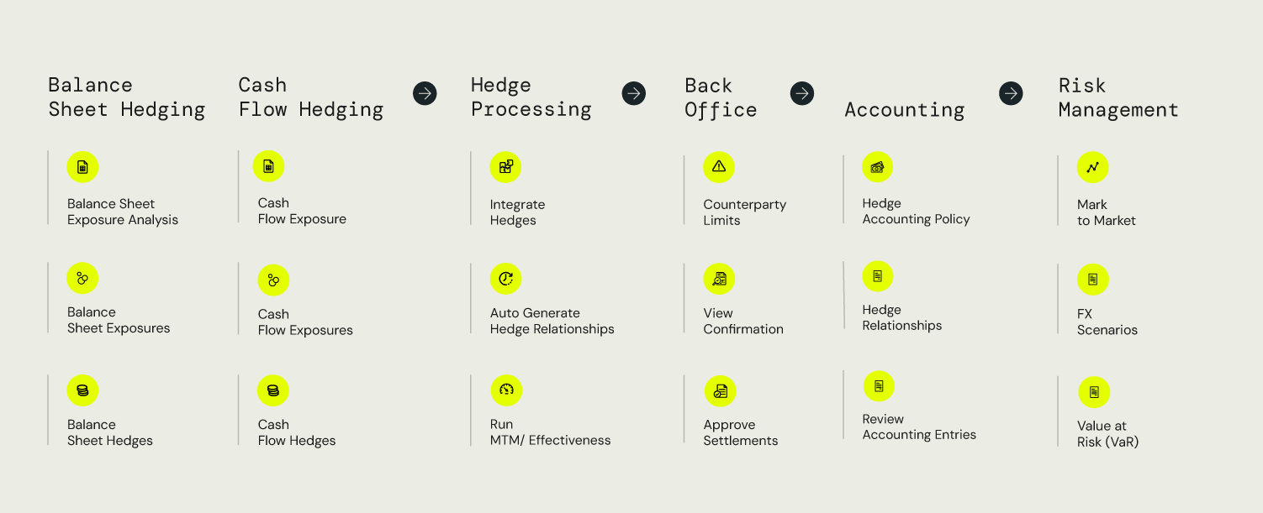
Applicable functions include hedge relationship definition, de-designation, quantitative and qualitative hedging documentation, current and historic hedge effectiveness results, regression analysis outputs and hedging portfolio reporting.

- Financial Accounting
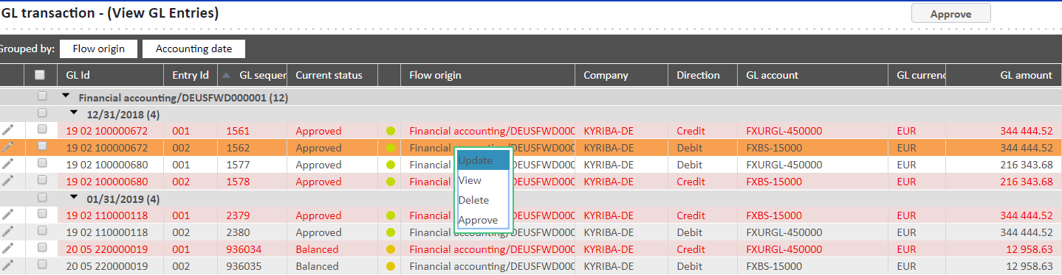
Kyriba allows accounting rules to be followed based on a set of deal-related matching criteria (compared to flow-based criteria for the cash accounting module) which can include many standard fields such as deal type, counterparty or deal indicator, and user defined fields such as a portfolio code. Kyriba includes a very high level of flexibility in the definition of calculation-based accounting rules (e.g. revaluation, accruals, hedge effectiveness), allowing for the straightforward support of many different accounting frameworks such as IFRS9 and ASC820. Sources of data include the position keeping, valuation modules and hedge accounting modules (see above); captured GL entries. Applicable functions include business rules definition; frequent accounting entries creation, approval and export; accruals and P&L calculation and reporting.

- Risk Analysis
Kyriba's Risk Analysis module enables clients to evaluate the effects of theoretical user-defined scenarios and produced Key Indicators on financial transactions in portfolio or simulated. While normal Kyriba revaluation uses the market data entered or imported into the system, Risk Analysis revaluations (or ‘what-if?’ scenarios) use data with tenor and curves distortions deliberately set in the scenario. Distortion involves applying a parallel shift of a selected number of basis points to all rates for a given yield curve or currency. A shock simulates the effects of a sudden or dramatic rise or fall in the FX or interest rates.
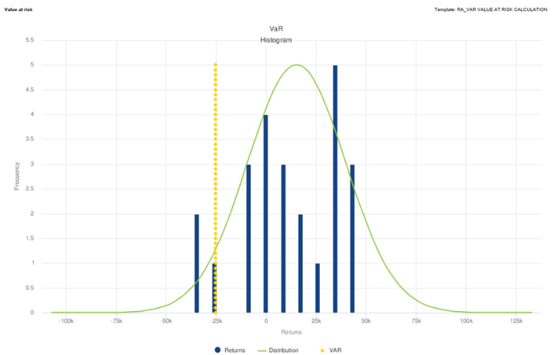
In addition to the above stress-testing function, Kyriba’s Value-at-Risk ("VaR") analysis quantifies the risk in a market position by estimating the maximum likely loss from changes in market prices, within a specified time period, with a specified level of confidence. Kyriba allows to apply certain parametric techniques to improve the precision of the quantile estimate. The presence of skewness and kurtosis affects the perception and measure of risk and the framework of risk-return optimization. Kyriba supports historical simulation, incremental and marginal VaR analysis. Reporting includes VaR figures per transaction and selected portfolios. Kyriba's methodology uses actual mark-to-market computed results only.
Kyriba's VaR Calculation models include:
Normal (default), Student-T, Cornish-Fisher, Johnson SU, Empirical.
Sources of data include the position-keeping module (see above); imported market data (yield curves, FX forward curves, FX and IR volatilities) from Kyriba's advanced data provider or customer's own.
Applicable functions include Scenario analysis and Value-at-risk reporting.

- Credit Risk
Kyriba can calculate CVAs and DVAs (credit / debit valuation adjustments) in report and hedge relationships so that investment portfolio valuations may, if required, be adjusted to reflect the issuing counterparty's current creditworthiness. Kyriba offers two CVA/DVA calculation methodologies, "Gross" and "Deterministic". ISDA netting agreement can be set up in Kyriba so that any in-scope transaction is included and CVA or DVA (depending on the asset or liability outcome of the net position) applied in reports.
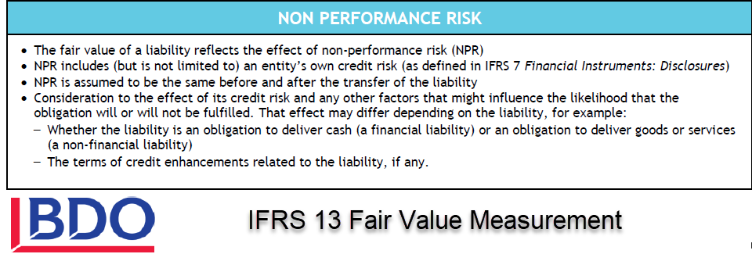
Sources of data include the position keeping module (see above); imported market data (yield curves, FX forward curves, FX and IR volatilities, credit curves) from Kyriba's advanced data provider or customer's own.
Applicable functions include credit curves definition and import, ISDA netting agreement setup; credit risk reporting at trade and portfolio level.

- Leases
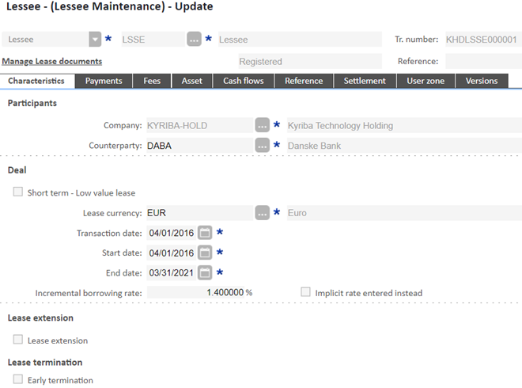
Kyriba supports the management of fixed and floating rate operating and financial leases. Kyriba is IFRS16 compliant with its ability to record leases, calculate all lease-related metrics (such as asset / liability value, cost of depreciation, implied lease rate…), define their schedule of payment and produce IFRS-compliant accounting entries. Kyriba’s lease module accounts for maintenance costs, residual value, stipulated losses, and embedded options, manages lifecycle events such as early termination, extensions, returns/renewals/purchases, and automatically generates the appropriate journal entries in Kyriba’s sub-ledger with further integration to General Ledger systems. Kyriba is not ASC842 compliant at this time.
Sources of data include imported or captured Lessee and Lessor financial transactions only.
Applicable functions include bulk modification and enrichment; forecast and settlement generation (where applicable), P&L, accrual, amortisation and maturity processes, trade confirmation letters; portfolio and deal-based reporting in nominal value (not marked to market); accounting business rules definition, GL entries creation, approval and export. Please note no Risk or Financial Transaction user is included in the Lease package.

FX Exposure Management - Balance Sheet
- Balance Sheet Base Platform
This solution enables the quantification, segmentation and comparison of exposure balances from forecasted and/or actual general ledger balance sheet accounts. All exposures are aggregated, defined and validated, analysed, managed and sent for execution with an automated workflow. This module looks at overall value invoices that are already booked.

FX Exposure Management - Cash Flow
- Cash Flow Base Platform
This solution enables the forecast creation, analysis, exposure summary, decision recommendations and trade preparation to be proactively managed and controlled. The Cashflow module looks at details such as income and expenditure and invoices before they are booked. This module enables treasury professionals to create, analyse and manage accurate cash flow exposure forecasts, increasing confidence in their hedging program.

Data and Analytics for Risk
- Risk Analytics
Kyriba's BI tool enables users to effectively analyse and optimise their strategic decision-making by delivering actionable insights and capabilities that unlocks value within the Kyriba treasury-related data. It elevates communication and strategic value, by increasing shareable insights, transforming data into information and reducing the time to research information in several locations.
Risk Analytics is a customer-specific data warehouse with a business-orientated data model dedicated to analysis. It stores historical over years and decades. Its embedded reporting is composed of cross-domain tables, views, measures and ready-made Key Performance Indicators. Risk Analytics delivers cross-domain customer-definable views, drag-and-drop abilities, advanced formulae, best-of-breed graphics, report package design and fully interactive dashboards.
Sources of data include data from the Position Keeping (especially the following reports: Ledger of all transactions, Loan breakdown, Schedule of events, Credit lines, Syndication of transactions), Accounting (especially the following reports: GL entry ledger, Generate amortization & accruals, Hedge allocation) and static data modules.
Applicable functions include four (4) off-the-shelf views:
- Overview
- What is the value of my different financial assets?
- What is the evolution of my debt?

- What is my transaction history?
Licensed Risk Analytics users have access to all 4 standard views in read-only mode and other personalised views in read-and-write mode.

- Liquidity Analytics
The Liquidity Analytics App gives powerful insights on the financial health of an organization and its resilience for the future. Its advanced analytical reports include:
- Analysing the variation of net debt and liquidity over time
- Simulating different scenarios to optimize the raising of debt
- Assessing how many days a company can survive with your current liquidity (or a simulated version
of them)
Sources of data include data from the Position Keeping (especially credit line, debt and investment transactions and cashflows), cash management and forecasting (especially bank balances, actuals and projected cashflows), as well as the static data modules.
Applicable functions include the data model dictionary, dozens of off-the-shelf “measures” and three (3) predefined reporting. Liquidity Analytics does not require any user access or right to be setup.
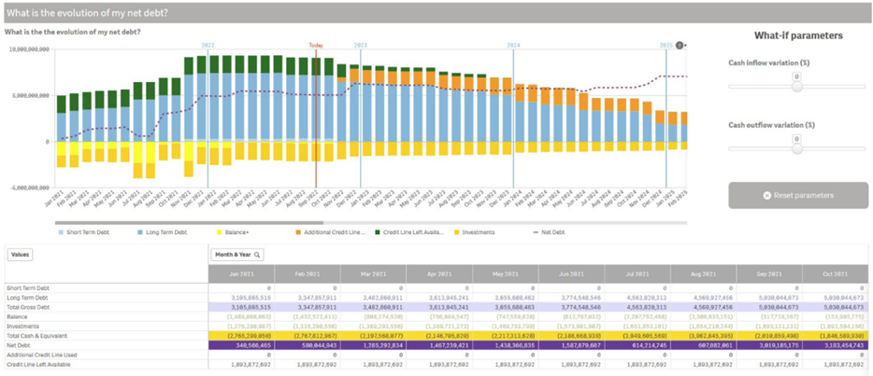
Other notable options
- Premium Market Data
Kyriba is delivered with its own valuation-related market data engine, allowing FX forward, yield curves, FX volatility surfaces as well as credit curves (6,000 data points currently) to be delivered and integrated without any further action from any customer.
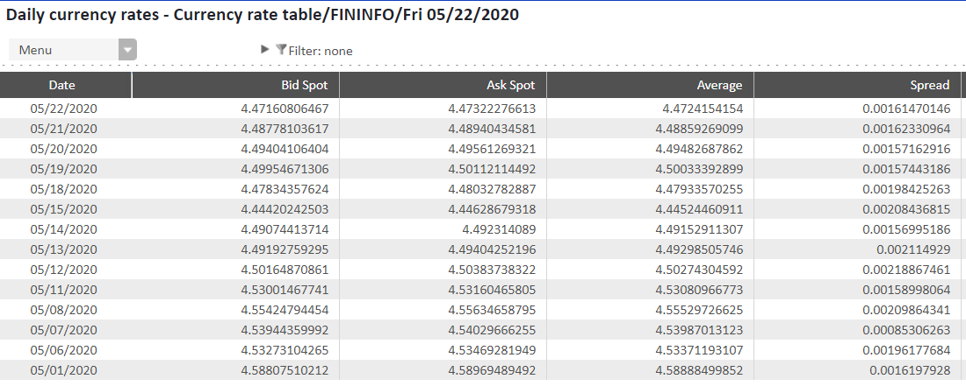
Sources of data for this option include
market-related static data such as currencies and interest indices.
Applicable functions include market data point definition and reporting for the following types, up to 380 market data points a day:
- FX spot (New-York, London, Tokyo, ECB, Central banks fixing): 800 spot rates currently available
- Money Market indices: 1,100 indices
currently available
Appropriate usages of this option are multi-currency cash positioning, reset (fixing) of interest rates on financial instruments, FX instrument spot rate indication and Non-Deliverable rates reset.
Once activated, all Cash, Payment and Risk user license tokens can access this function.
- Premium Market Data for Risk
Kyriba is delivered with its own valuation-related market data engine, allowing FX forward, yield curves, FX volatility surfaces as well as credit curves (6,000 data points currently) to be delivered and integrated without any further action from any customer.
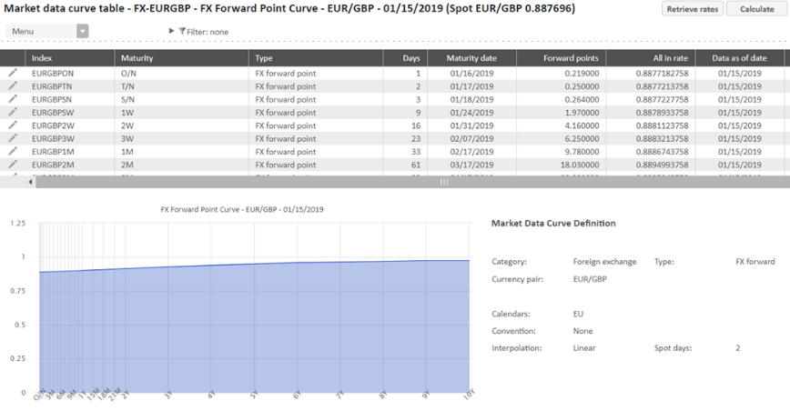
Sources of data for this option include market-related static data such as currencies, interest indices, FX and yield curves.
Applicable functions include market data point definition and reporting for the following types, up to 700 market data points a day:
- FX spot (New-York, London, Tokyo, ECB, Central banks fixing): 800 spot rates currently available
- Money Market indices: 1,100 indices
currently available
- FX forward points: 1,700 points currently available
- Zero-Coupon curves: 1,300 tenors currently available
- Interest Rate swap rates: 370 points currently available
On top of the above uses of the “Premium Market Data” option, the main use of this option is the valuation of all financial instruments managed in Kyriba (outside of FX and IR options) for up to 29 or 30 currencies. 700 data points effectively correspond to 29 currencies using 8 data points (on average) per zero-coupon and FX forward curves. Both ZC and FX curves are used by Kyriba’s valuation process.
Once activated, all Cash, Payment and Risk user license tokens can access this function.

- Premium Market Data for advanced Risk
Kyriba is delivered with its own valuation-related market data engine, allowing FX forward, yield curves, FX volatility surfaces as well as credit curves (6,000 data points currently) to be delivered and integrated without any further action from any customer.
Sources of data for this option include market-related static data such as currencies, interest indices, FX and yield curves, FX volatilities surfaces and credit curves.
Applicable functions include market data point definition and reporting for the following types, up to 1400 market data points a day:
- FX spot (New-York, London, Tokyo, ECB, Central banks fixing): 800 spot rates currently available
- Money Market indices: 1,100 indices
currently available
- FX forward points: 1,700 points
currently available
- Zero-Coupon curves: 1,300 tenors
currently available
- FX Volatility surfaces: 2,100 surface points currently available
- Credit Default Swap spread curves: 1,000 spreads currently available.
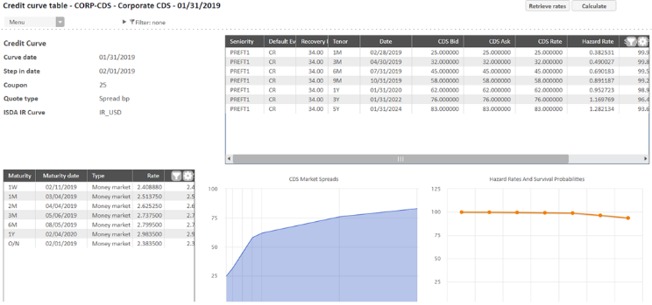
On top of the above uses of the “Premium Market Data for Risk” option, the ultimate use of this option is the valuation of most financial instruments managed in Kyriba (including FX options), eventually adjusted by debit and credit valuation and for more than 30 currencies.
Once activated, all Cash, Payment and Risk user license tokens can access this function.

- Advanced FX Valuation – FinCAD
Kyriba includes powerful simulation and optimization risk management tools. With the “Advanced FX Valuation – FinCAD” engine, users can apply valuations to average rate FX forwards (with averaging type "geometric") using FINCAD-provided analytics. The valuation methodology is based on implying the forward rate using put-call parity and therefore uses the default FX volatility surface as input to the calculation. Averaging type "Arithmetic" average rate FX forwards do not require this module.
Please note Asian Options are planned for release in Q1-2023, for which European Arithmetic & Geometric averaging will require this engine. Asian Options with American Arithmetic & Geometric averaging are currently out of scope: Asian Options with American Arithmetic averaging are planned for release in Q3-2023, alongside "Average Strike Options", both of which will require this engine.
Sources of data include the position-keeping module for average rate FX forwards buy and sell instruments; imported market data (FX forward curves, FX volatilities) from Kyriba's advanced data provider or customer's own.
When this option is activated, Risk users are able to run the Mark-to-Market Process on transactions whose code category is recorded as Average rate forward/Buy or Average rate forward/Sell.

- Advanced Interest Rates Valuation – FinCAD
Kyriba includes powerful simulation and optimization risk management tools. With the “Advanced Interest Rate Valuation – FinCAD” engine, users can apply valuations to Interest Rate Caps, Floors and Collars. The engine converts Cap and Floor Prices, from the selected market data feed, into stripped normal caplet/floorlet implied volatilities.
Sources of data include the position-keeping module for interest rate Caps and Floors, buy and sell instruments; imported market data from Kyriba's advanced data provider (Premium Cap/Floor Implied Volatilities data feed, see below) or customer's own.
When this option is activated, Risk users are able to run the Mark-to-Market Process on transactions whose code category is recorded as Cap, Floor or Collar (Buy and Sell).

- Premium Cap/Floor Implied Volatilities
Kyriba is delivered with its own Interest Rate Options valuation-related market data engine for interest rate implied volatilities, calculated from third party market data. Like the Premium Market Data services, Cap and Floor implied volatilities matrix tables are delivered and integrated without any further action from any customer. This feed is for the provision of interest rate implied volatilities to the Advanced Interest Rates Valuation – FinCAD engine. Sources of data for this option include market-related static data such as currencies, interest indices and
tenor codes.
Applicable functions include market data point definition and reporting for the following types:
- Premium Cap/Floor Implied Volatilities in one functional currency (USD, EUR, GBP, CAD, CHF, DKK, JPY, NOK, SEK, CZK, PLN)
- Further currencies may be available on request. Kyriba is currently providing IBOR-like rates.
Once activated, all Cash, Payment and Risk user license tokens can access this function.

- CaaS Connector - CME Datamine Term SOFR
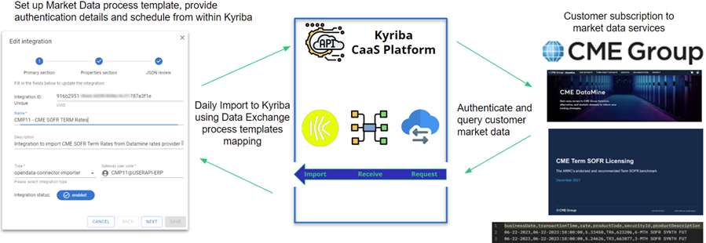
This innovative Kyriba marketplace connector enables customers to automate the integration of Term SOFR Reference Rates using their existing CME Datamine Subscription.
Sources of data for this option include market-related static data such as currencies, interest indices, FX and yield curves.
A prerequisite exists for this connector to work: a subscription to CME Group Term SOFR must be active. The import of Term SOFR rates into Kyriba then uses the customer’s CME Datamine credentials.
Once activated, all Financial Transactions and Risk users can use Term SOFR rates on related transactions for capture and processing.
- Working Capital
Kyriba’s Working Capital solutions provide flexible alternative supplier financing and receivable financing, delivering working capital improvements and unlocking cash and liquidity from the entire supply chain. The solution is completely integrated into Kyriba’s cloud financial management system and enables companies to generate free cash flow while reducing the risk of supplier disruption due to illiquidity, or leveraging their customer collection.
Kyriba’s Working Capital solutions include Supply Chain Finance, Dynamic Discounting and AR Invoice Financing to extend Days Payable Outstanding, improve net income and operational margin or reduce Days Sales Outstanding.
• Dynamic discounting programs reduce cost of goods sold through the direct discounts earned from suppliers, increasing net income while simultaneously improving the return on excess cash liquidity. Those programs are best suited for corporates that have excess cash and liquidity, designed for organizations looking for an alternative to low yield short-term investments
• Supply Chain Finance, also referred to as Reverse Factoring, facilitates term extension on payables, preserving cash for longer on the balance sheet and increasing free cash flow.
• Invoice Financing, also referred to as Factoring, enables the sale of receivables to a finance provider at a discount, accelerating cash collection in bank and on the balance sheet, thus also increasing free cash flow.
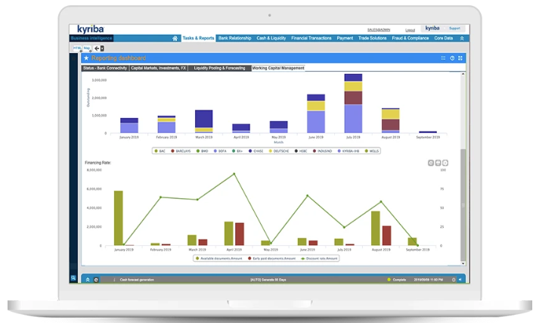
In all solutions, the tri-partite workflow is straightforward and designed with the supplier or seller in mind. Approved invoices are uploaded from the buyer’s or seller’s ERP, while suppliers elect which invoices they prefer to be paid early in the portal itself. The platform then calculates the payment required, based upon the agreed terms, integrate with the ERP to update the terms while either buyer or financing partner are able to agree and to process the requested early payments.
Kyriba’s working capital solutions are seamlessly integrated with major ERPs, as well as with Kyriba’s other capabilities for cash, risk management and payments. Kyriba’s platform also features connectivity to local and international liquidity providers. On the financing partner side, Kyriba’s platform is designed to interface with a wide variety of bank applications, and can easily adapt to the third-party systems that banks are using to book loans and generate payments.
To maximize suppliers’ participation in the payable Financing programs, Kyriba supports its clients to help identify potential suppliers for the program, quantify the value of supplier participation, solicit supplier participation, and enable suppliers on the cloud platform. CFOs and senior finance leaders are under mounting pressure to generate additional free cash flow and improve EBITDA for their organizations. Kyriba’s Working Capital solutions have proven to be a big success in helping CFOs extend payment terms and better manage working capital.
Trade Solutions
- Reverse Factoring
Kyriba's suite of Working Capital solutions proposes a single bank-agnostic portal to all three parties acting on Supply Chain Financing Programme:
1. The Buyer, who is able to import invoices from ERP, configure the whole list and associated funding conditions of participating suppliers, manage potential tri-partite disputes, documents and uploads the relevant Financing Contracts from participating Reverse Factoring banks or
funding partners.
2. The Supplier: after invoices upload and approval from the Buyer, any single- or multi-company supplier can quickly enter an early financing request directly from the portal start page, display the requested, pending and available financing, latest financing rate applicable by company or supplier. Disputes can be raised and resolved, early financing can be set as automatic after invoice pre-approval. A supplier local validation workflow can be enforced in collaboration with the buyer, as well as compliance to its own maximum financing limit at any one time.
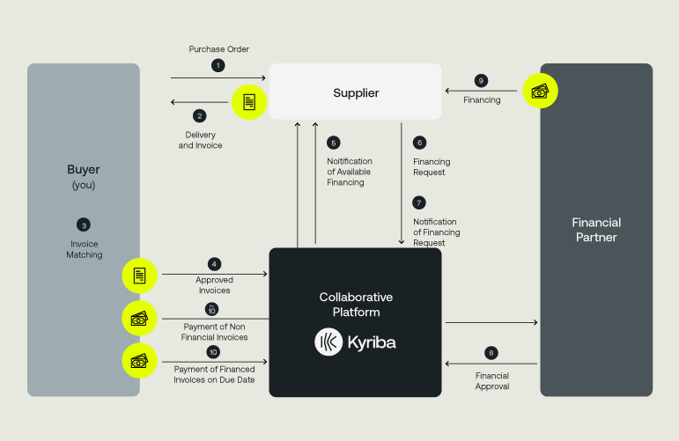
3. The Financial Partners' Workspace allows for reception and download of the financing requests' files per relevant criteria, as well as the ability to approve (or upload) online answers to pending requests. Reporting to all Financial Partners include pending requests, history of requests for funding and associated rates.
Sources of data include supplier invoice and document capture, invoice and document import from ERP and third party systems.
Applicable functions include
- On the Buyer and Financial Partner portal: Supplier enrolment, Integration and Export of documents, Document batch modification, Automatic early payment, Early payment requests Export to the funder, Outstanding early payments, Early payment statistics, Early payment distribution, Early payment activity, Discounting distribution, Outstanding discounting, Payment generation, Discounting dashboard, Statements delivery to suppliers;
- On the Supplier portal: schedule of documents, Invoices report, New early payment and at-maturity Payments views, Discounting history and Early payment history reports
Buyer’s and Financial Partner’s users have access to all Capture (“Add/Maintain”), onscreen reporting (“Inquire”), fixed reporting (“Report”), Processing and setup functions. Supplier users have access to the functions available on the Supplier portal.
- Reverse Factoring - Financing Fees
Kyriba’s transaction fee (quoted as an annual percentage rate) applied on top of or included into the Financing Partner’s rate proposed to supplier for early payment in a Reverse Factoring / Supply Chain Finance programme.

- Dynamic Discounting
Kyriba's suite of Working Capital solutions also proposes an integrated portal to Buyer and Supplier parties acting on a Dynamic Discounting Payable Programme:
1. The Buyer, who is able to import invoices from ERP, configure the whole list and associated funding conditions of participating suppliers, manage potential disputes and invoice documents.
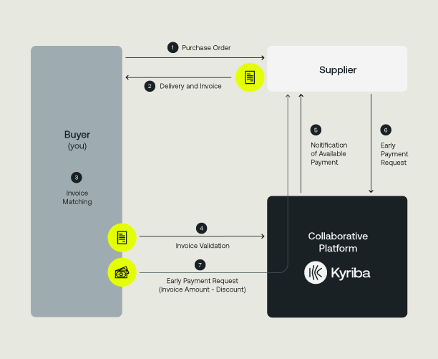
2. The Supplier: after invoices upload and approval from the Buyer, any single- or multi-company supplier can quickly enter an early financing request directly from the portal start page, display the requested, pending and available financing, latest financing rate applicable by company or supplier. Disputes can be raised and resolved, early financing can be set as automatic after invoice pre-approval. A supplier local validation workflow can be enforced in collaboration with the buyer, as well as compliance to its own maximum financing limit at any one time.
Sources of data include supplier invoice and document capture, invoice and document import from ERP and third party systems.
Applicable functions include
- On the Buyer portal: Supplier enrolment, Integration and Export of documents, Document batch modification, Automatic early payment, Outstanding early payments, Early payment statistics, Early payment distribution, Early payment activity, Discounting distribution, Outstanding discounting, Payment generation, Discounting dashboard, Statements delivery to suppliers
- On the Supplier portal: schedule of documents, Invoices report, New early payment and at-maturity Payments views, Discounting history and Early payment history reports
Buyer’s and Financial Partner’s users have access to all Capture (“Add/Maintain”), onscreen reporting (“Inquire”), fixed reporting (“Report”), Processing and setup functions. Supplier users have access to the functions available on the Supplier portal.

- Dynamic Discounting - Discount Earning Fees
Kyriba’s transaction fee (quoted as an annual percentage rate) applied on top of or included into the Buyer’s rate proposed to supplier for early payment in a Dynamic Discounting programme.

- Receivables Finance - Core
Kyriba's suite of Working Capital solutions also enables CFOs to unlock funds tied up in outstanding accounts receivable (AR), converting those assets into cash quickly. As customers of Kyriba, invoice sellers can centralize and simplify all receivables finance programs into the Kyriba portal, without having to change online funding providers in order to draw down from their credit facilities.
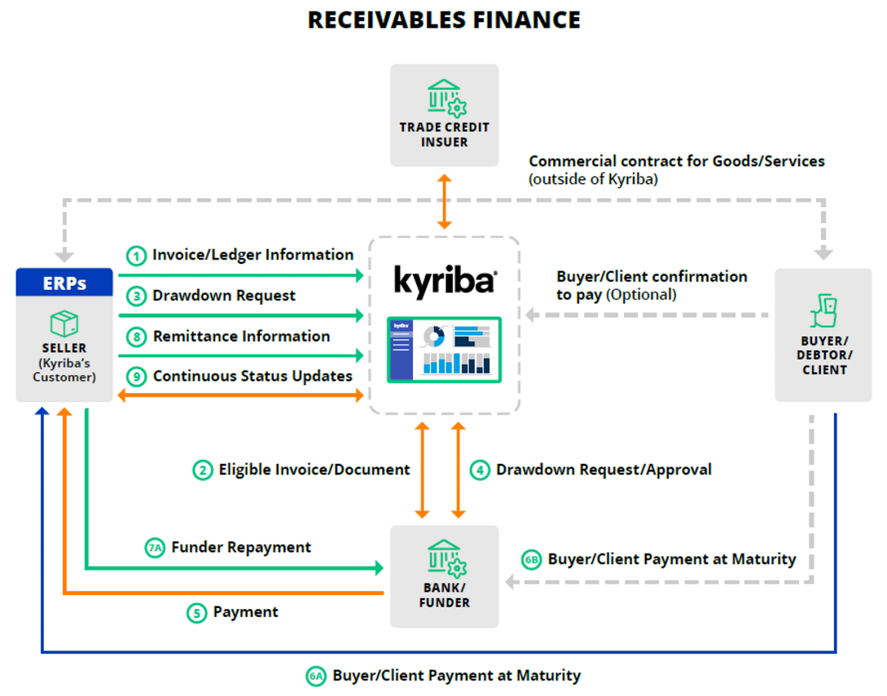
Using certified APIs or personalised ETL structure, the platform automates connectivity with the seller’s ERP system(s), providing analytics on AR. The platform allows sellers to sell the receivable automatically to the relevant funders and finance automatically selected receivables. Both Selective Debtor and Pooled Receivables Finance methods are activated in this solution.
Sources of data include customer invoice and document capture, invoice and document import from ERP and third party systems.
Applicable functions include: Integration and Export of documents, Document batch modification, Pool finance calculation, Automatic early payment, Outstanding early payments, Early payment statistics, Early payment distribution, Early payment activity, Discounting distribution, Outstanding discounting, Payment generation, Funder discounting dashboard.
Seller’s and Financial Partner’s users have access to all Capture (“Add/Maintain”), onscreen reporting (“Inquire”), fixed reporting (“Report”), Processing and setup functions. The buyers (or debtor clients) do not have access to the platform.

- Receivables Finance - Discount Earning Fees
Kyriba’s transaction fee (quoted as an annual percentage rate) applied on top of or included into the funder’s rate proposed to seller for early payment in a Receivables Finance programme.

Supplier On boarding Solutions
- Supplier Onboarding - Web site
Kyriba is delivered with a customizable supplier on-boarding website in order to entice target suppliers to look into the Reverse Factoring or Dynamic Discounting programme setup by a Buyer, customer of Kyriba. It aims to provide an online point of contact and the first tracking stage of a Payable Financing programme enrolment success.
In terms of Content management, Kyriba offers the possibility for the Financial Partner and for the buyer to design and modify the content of every website from an off-the-shelf template. The design is done outside of a management console that requires no technical or deep web design knowledge. The web site template includes:
- A Programme content section: Presentation of the SCF program (description, brochure, contract type…)
- Pages/blocks to display/hide selection
- The ability to select and update Logos and colours
- A Language selector accessible to the website user
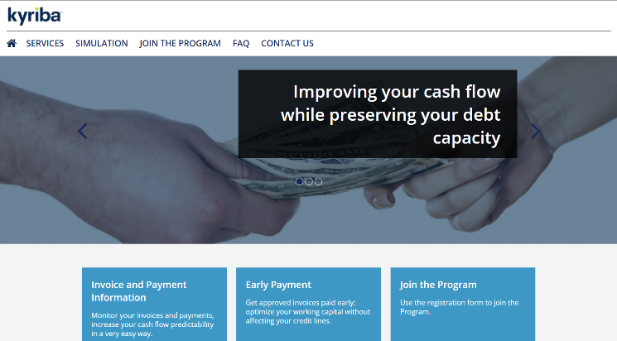
The On-boarding Web Site has also responsive design for PC, tablet and smartphone

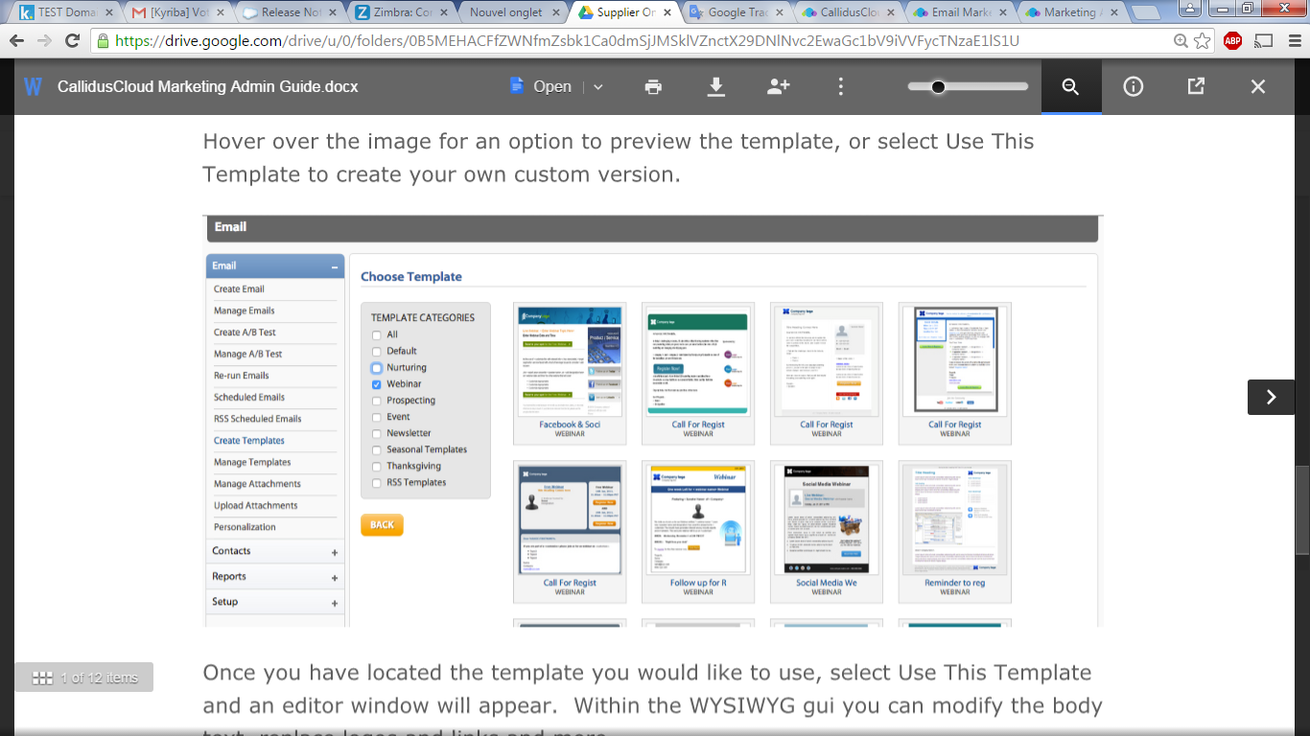
- Supplier Onboarding - Emailing
As part of its Supplier On boarding Solutions, Kyriba is embedded with email campaign setup and automation targeting the Suppliers to invite to join the early payment programme. It allows Buyers (clients of Kyriba) to manage tasks related to supplier calls, meetings, and documentation to send
to suppliers.
The email solution allows Buyers and Financing Partner users in charge of supplier on boarding to create template easily and send email campaigns, and track suppliers’ behaviour in response to
those campaigns.

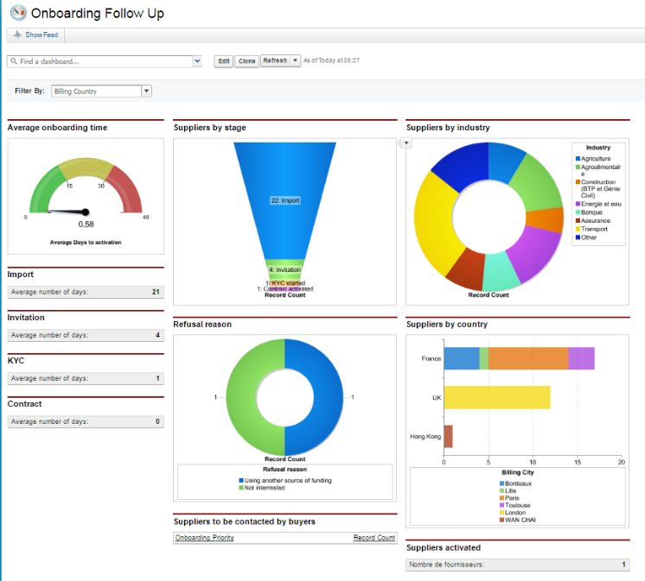
- Supplier Onboarding - Reporting
Kyriba's Supplier On boarding Reporting Solution provide Buyers (clients of Kyriba) with visibility on each supplier on boarding status. It includes links to the supplier email messaging solution by updating users on the status of running and past email campaigns. The reporting solution is managed within Kyriba's itself, tracks past and future communications with Suppliers and reports on their on boarding status.
This function includes the following three sets of Key Performance Indicators to the suppliers’
enrolment success:
- Programme KPIs related to the overall on boarding progress: % of invited / enrolled suppliers, Conversion rate, Refusal reasons...
- On-boarding website KPIs (usual Google Analytics metrics applied to the landing website): number of visitors, pages visited, bounce rate, average time per visit and page, content access rate
- Email campaigns KPIs: Number of sent / delivered / opened / clicked emails,
spam rate

Data and Analytics for Working Capital
- SCF Analytics

Kyriba's BI tool enables users to effectively analyse and optimise their strategic decision-making by delivering actionable insights and capabilities that unlocks value within the Kyriba treasury-related data. It elevates communication and strategic value, by increasing shareable insights, transforming data into information and reducing the time to research information in several locations.
SCF Analytics is a customer-specific data warehouse with a business-orientated data model dedicated to analysis. It stores historical over years and decades. Its embedded reporting is composed of cross-domain tables, views, measures and ready-made Key Performance Indicators. SCF Analytics also delivers cross-domain customer-definable views, drag-and-drop abilities, advanced formulae, best-of-breed graphics, report package design and fully interactive dashboards.
Sources of data include data from the SCF (invoice documents, early payment request, programme setup, buyers, suppliers, funders), and static data modules.
Applicable functions include four (4) off-the-shelf views:
- Overview
- What is the evolution of the supplier onboarding?
- How many documents have been uploaded?
- Which invoices are financed?
Licensed Analytics users have access to all 4 standard views in read-only mode and other personalised views in read-and-write mode.

- Connectivity Solutions
Bank Connectivity
- Bank Reporting - Concentrator [also in Kyriba for Mid-Market]
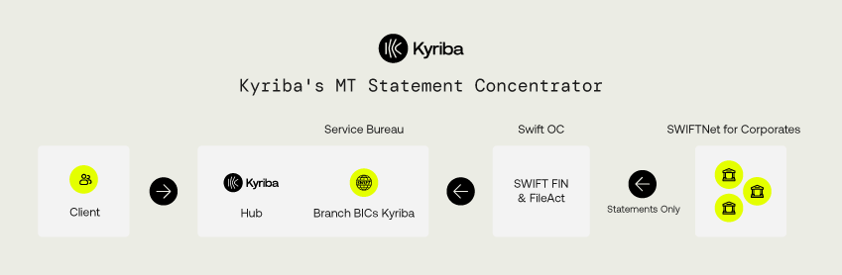
Kyriba’s Statement Concentrator (or “aggregator”) service stands for the import of prior and intra-day statements in MT940 and MT942 formats through Kyriba’s own BIC on the SWIFT network (BREDFRPPKYR for Europe, BREDFRPPKAS for Asia, BREDFRPPKUS for the US). Kyriba is integrated into its own Service Bureau+, delivering not only accesses to SWIFTNet for Corporates (Kyriba being the largest BIC provider for corporates over the whole SWIFT network) alongside its own concentrator service (not a third party's).

This option represents the number of bank accounts (and not branches or banking groups) activated on the statement concentrator service at Kyriba’s Service Bureau+.
Sources of data include prior and intra-day statements received from banks and accounts selected by the customer and enabled in our Service Bureau+.
Applicable functions include embedded SWIFTNet channel for statements.

- Bank Reporting [also in Kyriba for Mid-Market]
This option represents the number of banking groups (not country branches) connected into Kyriba using alternative methods than Kyriba’s Statement Concentrator, such as host to host connections (FTP, SFTP, FTPS), SWIFT AL2 and SWIFT Service Bureau. It stands for Kyriba’s cost to maintain connections in order for customers to receive bank statements directly from bank servers through Kyriba Hub. This option excludes Kyriba’s banking APIs, available through the “Advanced Bank Reporting Connector” option below.
Sources of data include prior and intra-day statements received from banks and accounts selected by the customer, whose bank connectivity has been enabled via host-to-host, API and SWIFT Service Bureau.
Applicable functions include statements connectivity technical (Hub) and functional (menu-based) setup.

- Bank Payments [also in Kyriba for Mid-Market]
As above for statements, Kyriba’s connectivity service for payments can be achieved over a range of channels and protocols, using formats compliant with the business objective of each payment type and defined prior to contract. Those payment channels include local and regional connectors hosted by Kyriba (BACS, Editran, CBI, ebics, Zengin …), host-to-cost connections (sFTP, FTPS as agreed with banks on an individual basis), and SWIFTNet for Corporates with customer’s own BIC (through Kyriba’s Service Bureau+ or Alliance Lite 2 for Business Application). This option excludes Kyriba’s banking APIs, available through the “Advanced Bank Payment Connector” option below.
This option stands for Kyriba’s cost to maintain connections in order for customers to send securely payments to bank directly from Kyriba Hub to bank servers.
Sources of data include imported payment files or batches, manually captured payment orders, financial transactions’ payment instructions (where applicable).
Applicable functions include embedded connectivity channel for payments.

- Bank Payments - Concentrator [also in Kyriba for Mid-Market]
Kyriba’s Payment Concentrator service stands for the release of urgent payments in MT101 format through an independent BIC on the SWIFTNet for Banks network. It is applicable only to same-day / High-Value Domestic & Cross Border payments via a SWIFT Service Bureau+ partner of Kyriba.
With this option, our customers do not require to become a SWIFTNET for Corporates member and obtain their own BIC. Its cost is calculated per account.

- SWIFTNET Service Bureau
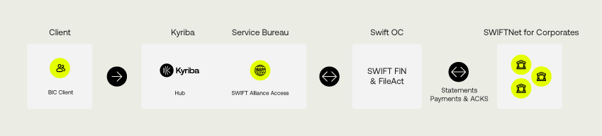
Kyriba enables access to SWIFTNet for Corporates to its customers with their own BIC hosted by Kyriba’s Service Bureau+. FIN protocol allows for the usual SWIFT files part of the MTx series to be processed (e.g. MT940 for statements sent by bank, MT101 for urgent payment sent to bank). FileAct allows non-FIN formats to be included into message envelopes sent to the bank using a dedicated secure channel over SWIFTNet. With this bank connectivity protocol, both options allow for both SWIFTNet channels to be used depending on bank capabilities, cost and other parameters (such as repudiation, Real-Time Gross Settlement…).
Kyriba has "SWIFTReady - Treasury" labelling accreditation from SWIFT. Plug and play interfaces are available for the following FIN and FileAct message types: MT101, MT103, MT199, MT202, MT210, MT940, MT942 and MT999 as well as XML messages pain.001.001.10, pain.002.001.11, camt.052.001.08, camt.053.001.08, camt.054.001.08 and camt.086.001.02. These encompass payments/wires, bank account balance, transaction reports/statements and bank service billing messages. SWIFTReady labelling means that Kyriba has successfully passed SWIFT's rigorous accreditation process, which tests the accuracy of the creation, interpretation and transmission of
standard messages.
This option stands for the monthly subscription to SWIFTNet for Corporates via Kyriba’s SWIFT Service Bureau+. It does not include initial setup cost, SWIFT messaging fees (both charged by Kyriba on top of the current option) and bank fees (charged by the bank directly).
Sources of data include prior and intra-day statements, imported payment files or batches, manually captured payment orders, financial transactions’ payment instructions (where applicable).

- SWIFTNET AL2 Service [also in Kyriba for Mid-Market]
As an alternative to the SWIFTNET Service Bureau connectivity, this option stands for the monthly subscription to SWIFTNet for Corporates via Kyriba’s Alliance Lite 2 for Business Application on behalf of the customer. It does not include initial setup cost, SWIFT messaging fees (both charged by Kyriba on top of the current option) and bank fees (charged by the bank directly). This option is not applicable to an AL2 option maintained by the customer itself.
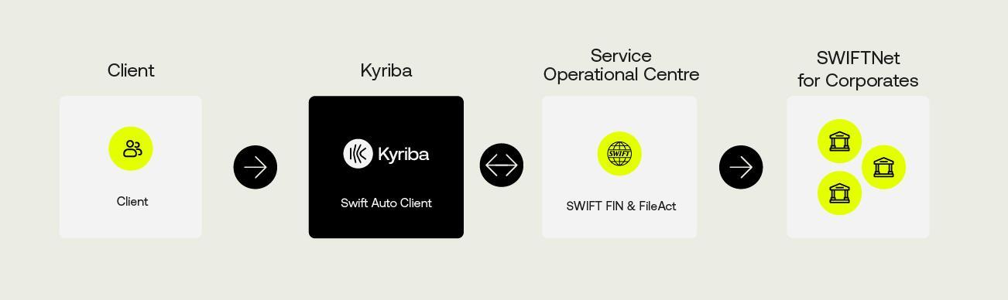
Sources of data include prior and intra-day statements, imported payment files or batches, manually captured payment orders, financial transactions’ payment instructions (where applicable).

- Local and regional networks subscriptions: FIRST, Editran, CBI, BACS, China
Those 5 options stand for the monthly subscription to the applicable territories of each protocol: FIRST in Japan, Editran in Spain, CBI in Italy, BACS in United Kingdom and the upcoming connection to the Chinese Bank network. Initial setup costs do not apply as those connections are managed by Kyriba and part of consulting services. Regular messaging fees do not apply as those would generally be included in local bank fees, charged by the issuing bank directly.





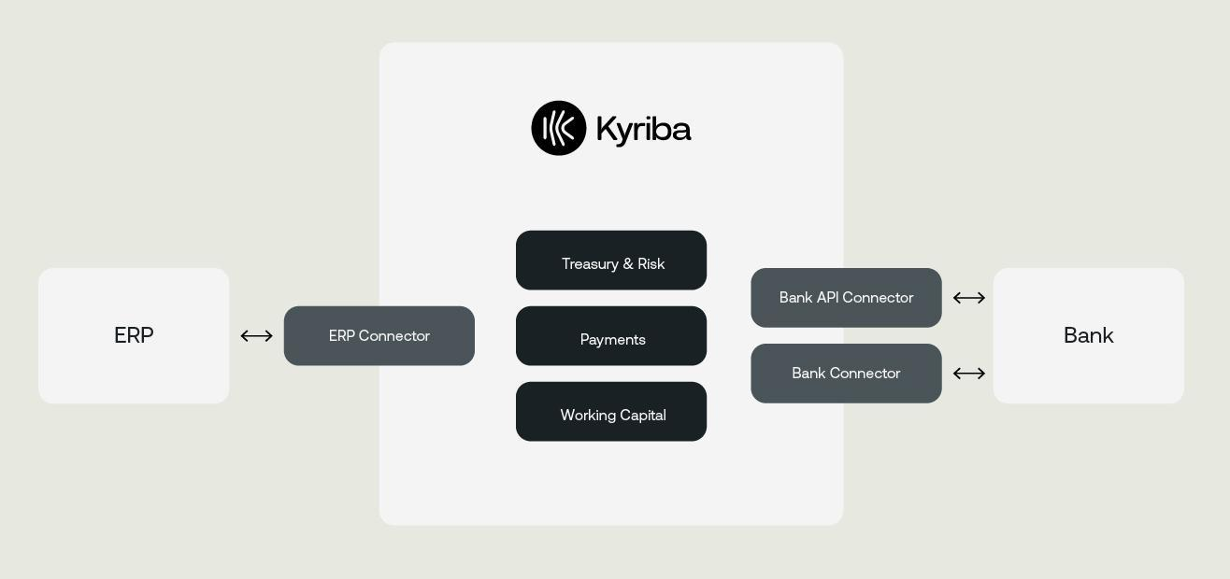
- Advanced Bank Payments Connector
Kyriba’s connectivity service for payments can be achieved over a range of channels and protocols, using formats compliant with the business objective of each payment type and defined prior to contract. Advanced Bank Payments Connector includes Bank APIs, local and regional connectors hosted by Kyriba, host-to-cost connections (sFTP, FTPS as agreed with banks on an individual basis), and SWIFTNet for Corporates with customer’s own BIC (through Kyriba’s Service Bureau+ or Alliance Lite 2 for Business Application). This option adds Open Banking API connectivity to the “Bank Payment” option earlier mentioned.
This option stands for Kyriba’s cost to maintain connections in order for customers to send securely payments to bank directly from Kyriba Hub to bank servers.
Sources of data include imported payment files or batches, manually captured payment orders, financial transactions’ payment instructions (where applicable).
Applicable functions include embedded connectivity channel for payments.

- Advanced Bank Reporting Connector
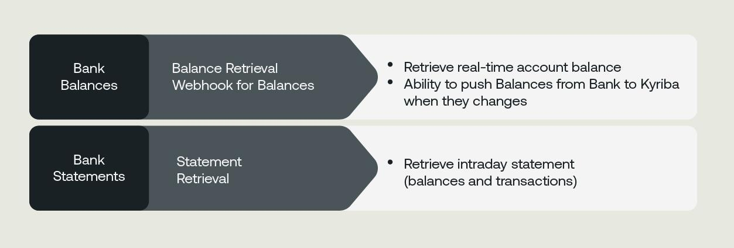
This option represents the number of banking groups (not country branches) connected into Kyriba using alternative methods than Kyriba’s Statement Concentrator, such as host to host connections (FTP, SFTP, FTPS), SWIFT AL2 and SWIFT Service Bureau. It stands for Kyriba’s cost to maintain connections in order for customers to receive bank statements directly from bank servers through Kyriba Hub. This option adds Kyriba’s Open Banking APIs, to the “Bank Reporting” option earlier mentioned.
Sources of data include prior and intra-day statements received from banks and accounts selected by the customer, whose bank connectivity has been enabled via host-to-host, API and SWIFT Service Bureau.
Applicable functions include statements connectivity technical (Hub) and functional (menu-based) setup.

ERP Connectivity
- ERP Connector - SAP
Kyriba SAP Connectors accelerates SAP Treasury and Liquidity projects, eliminates project risk and drastically reduces connectivity costs by providing SAP-certified APIs for a selected range of Kyriba’s solutions. Current SAP API certification applies to payment and Payables Financing (SCF and Dynamic Discounting) to both SAP ECC6 and S/4
HANA platforms.
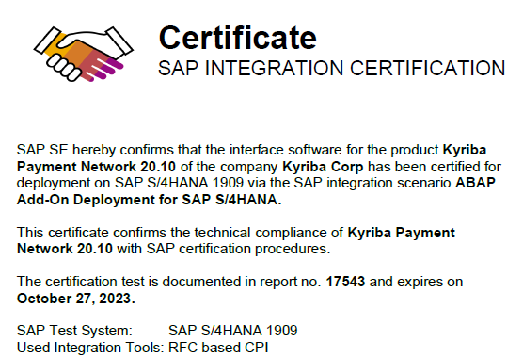
Seamless integration with SAP payments processing allows vendor payments and other third party transfers to flow through the Kyriba Payments Network, which is responsible for
payment screening, added workflow, payment formatting and bank communication through various connectivity protocols.
Kyriba certified API to the SAP ERP platforms provides a complete end-to-end solution for Supply Chain Finance (SCF) workflows as well, in order to :
- Extract Receivables, open documents for SCF Suppliers, map the data to Kyriba, and create documents in Kyriba automatically
- Discount Receivables, as early payment requests and updated documents are imported into SAP, automatically assigning the alternate payee of the document.
- Collection & Reconciliation extracts cleared items from SAP after a payment run, transmits them to Kyriba, initiates the reconciliation process and updates the document settlement
status automatically.

- ERP Connector - Oracle
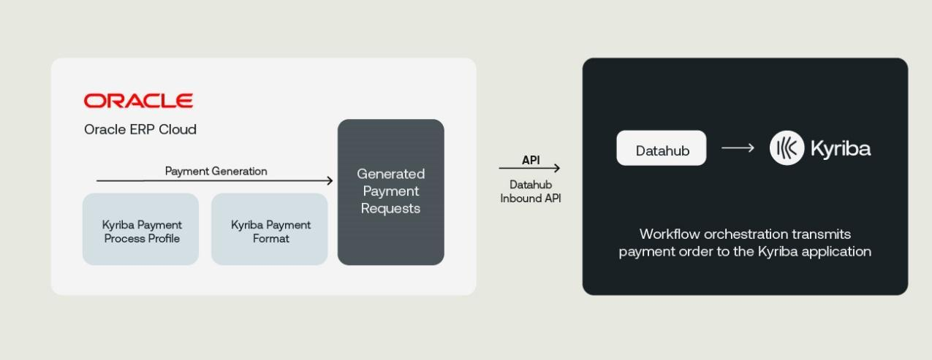
Kyriba Oracle Connectors accelerates SAP Payment projects, eliminates project risk and drastically reduces connectivity costs by providing Oracle-certified APIs for a selected range of Kyriba’s solutions. Current Oracle API certification applies to Kyriba’s payment solution, for both Oracle Cloud and E-Business Suite platforms.
Seamless integration with Oracle payments processing allows vendor payments and other third party transfers to flow through the Kyriba Payments Network, which is responsible for
payment screening, added workflow, payment formatting and bank communication through
various connectivity protocols.
- NetSuite API Connector [also in Kyriba for Mid-Market]
Kyriba SuiteApp, built using NetSuite’s SuiteCloud Computing Platform, has a 'Built for NetSuite' API. This ensures that Kyriba's solution meets the same level of standards for security, data privacy and overall quality as the solutions offered by NetSuite.
Kyriba's NetSuite API is a secure client of the NetSuite Web Service API. It brings automated, bi-directional data exchange between Kyriba and NetSuite, by automating several daily treasury workflows: payments, GL export, GL reconciliation, forecasts, checks.
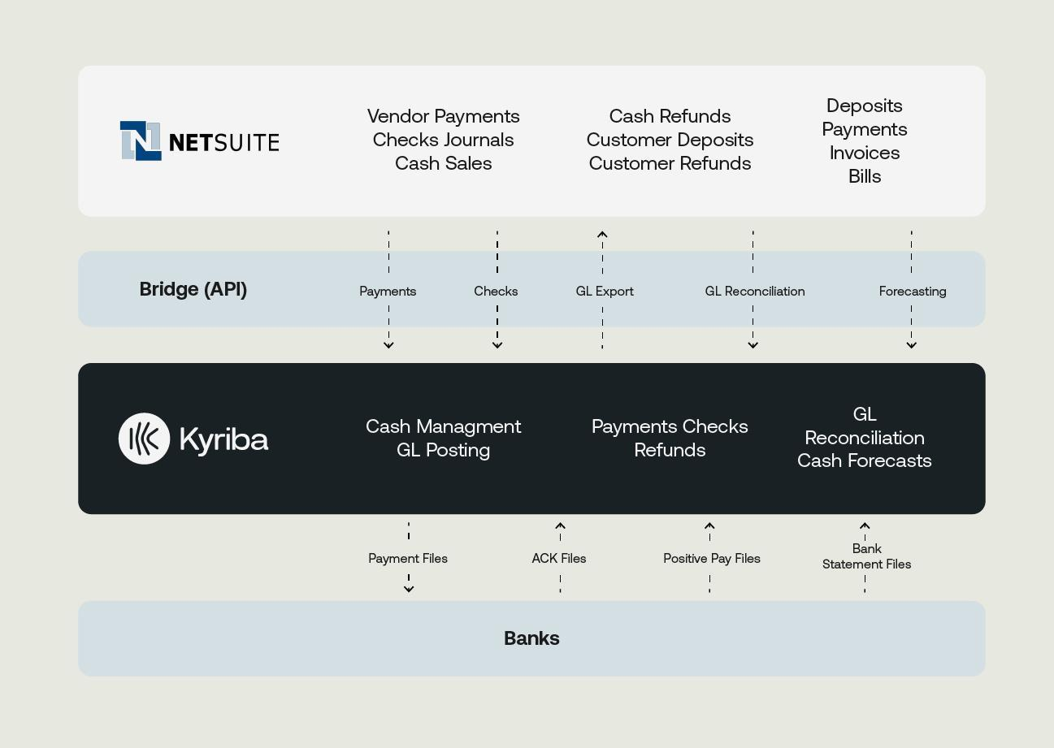
Kyriba's NS API does not require any technical setup, as it is already connected to both Kyriba and NetSuite clouds: it only requires an Account Manager activation of the service to establish the Single Sign-On ("SSO") link between platforms.
No user credentials are shared: SSL keys are exchanged between Kyriba and NetSuite once for all while platforms communications are always encrypted and authenticated over the cloud.
There is no design or development required as the exchange content is pre-established in the API. The NS API includes a standard yet extensible set of fields in NetSuite to cover imported payment details. Extended and new functionalities are regularly added by Kyriba.

- ERP Connector - Dynamics 365 Finance
Kyriba’s packaged integration to Dynamics 365 provides a complete end-to-end solution for common workflows between D365 and the Kyriba applications, enabling access to these solutions:
- Payments and Payment Status
- Cash Forecasting
- Cash Management
- GL export
- GL Reconciliation
- Foreign Exchange/Balance Sheet
Sources of data include prior and intra-day statements received from banks and accounts selected by the customer, whose bank connectivity has been enabled via host-to-host, API and SWIFT Service Bureau.
Applicable functions include statements connectivity technical (Hub) and functional (menu-based) setup.
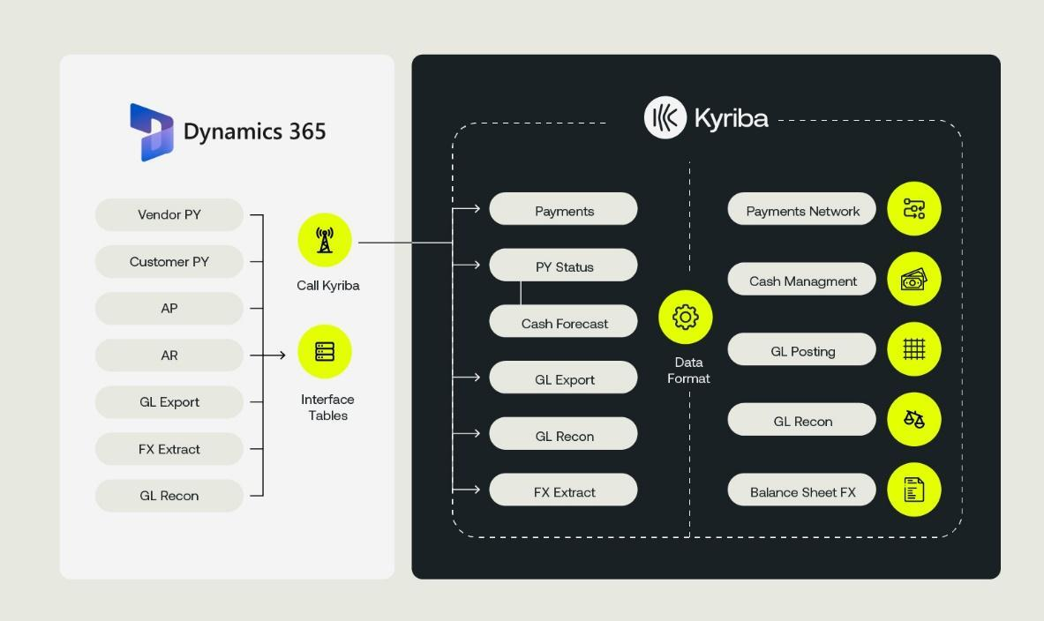

API-based value-add connectors
- API Platform
Kyriba built a marketplace of real-time connections to apps, data, and new products and services that inject data-driven decision making into every financial operation. In this API platform, Kyriba has extended its APIs to cover all key workflows required by customers, such as reference data management, payments, liquidity, risk, and working capital optimization.
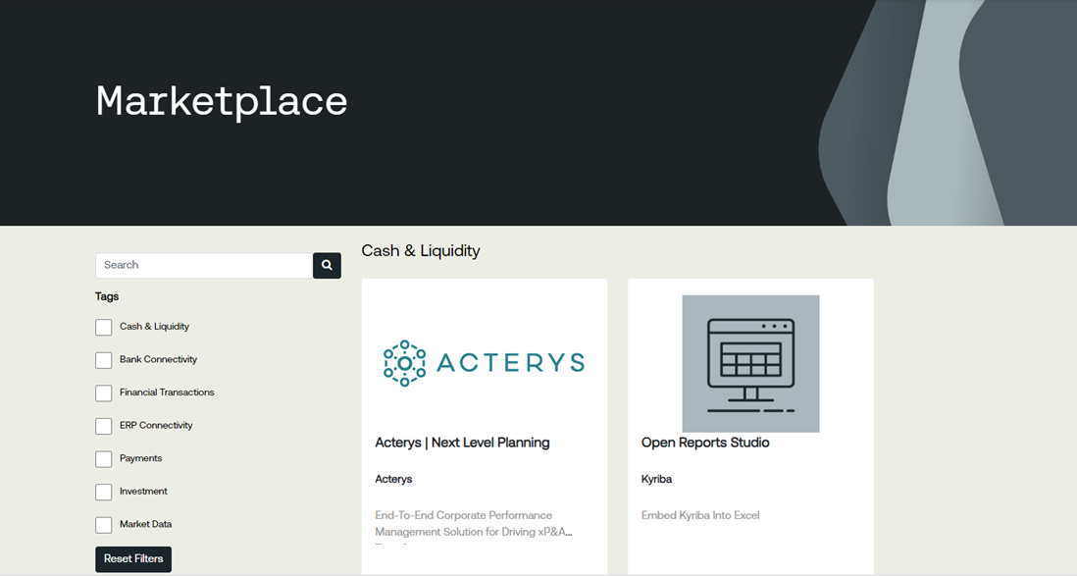
The API Platform gives access to new products and services that are accessible through Kyriba’s Developer Portal, which connects partner solutions, certified and integrated with Kyriba. Kyriba’s API marketplace currently includes ERP Connectivity, Payments and Investments apps, as well as Kyriba’s own APIs which partners can use to extract from and push information to.

- Open Reports Studio
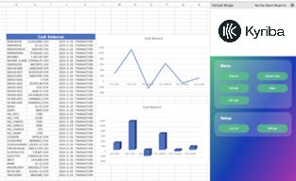
Kyriba Open Reports Studio is a powerful and easy-to-use Microsoft Excel add-in that seamlessly integrates with the Kyriba Enterprise Liquidity Management platform. It allows bilateral data management directly from Excel, with extra functions provided by the Kyriba APIs.
The add-in offers the following features:
- Reports: allows users to download data from Kyriba to Excel and build any report out of the downloaded data.
- Upload Data: allows users to upload data from Excel to Kyriba, such as account information, payments, and invoices.
- Custom Functions: allows users to retrieve data from Kyriba via API using Excel syntax. There are now 9 functions designed for advanced business users, including a Kyriba.AskGPT function that enables the use of ChatGPT within Excel for users who have a ChatGPT account.
- Technical Process Token
The Technical Process Token allows the user-less automation of Kyriba’s processes, such as running templates, leveraging an API, processing batches, etc. within the product.
Previously these capabilities would have required a user ID to be assigned exclusively for this purpose. By using this automation user license, all business users ID are available for physical users to access the Kyriba platform.
Setup and Impact fees
- SWIFTNET Setup
This option stands for the one-time joining fee charged by SWIFT to Kyriba when setting up a customer on the Service Bureau+. This is a mandatory fee applicable to the SWIFT Service Bureau activation for a customer.
- SWIFTNET AL2 Setup [also in Kyriba for Mid-Market]
This option stands for the one-time joining fee charged by SWIFT to Kyriba when setting up a customer on Kyriba’s Alliance Lite 2 for Business Application. This is a mandatory fee applicable to SWIFT L2BA activation.
- Bank Reporting Volumes [also in Kyriba for Mid-Market]
When external bank connectivity statement services are enabled, Kyriba provides proactive platform and connection monitoring to all its customers as well as provisioning an unlimited server size to store banking information into the application. The cost of those services corresponds to this item when managing electronic bank statements.
Sources of data include prior and intra-day statements received from banks selected by the customer and enabled in the relevant channel. Impact volume calculation for Bank Reporting includes all statement records reportable and readable in Kyriba, i.e. account header, line transactions and account footer.
Applicable functions include statements storage, data consistency and availability.
- ERP Transactions Volumes [also in Kyriba for Mid-Market]
As part of a Payment Hub or Factory setup, Kyriba imports or routes sensitive payment instructions coming from ERP (and other third party systems) through its network and application. The cost of this service corresponds to this item when managing imported payment instructions.
In the case of Cash, Liquidity and accounting processing, this database impact fee also corresponds to
- imported ERP transactions for forecasting and forecast-to-bank reconciliation purposes,
- General Ledger entries imported for bank-to-book reconciliation purpose,
- accounting entries generated by Kyriba and sent to General Ledger systems.
Sources of data include imported payment files or batches in “integration” mode, imported forecast transaction, imported and exported GL entries. Applicable functions include payment order storage, forecast storage, GL entries storage, data consistency and availability.
- Payment Volumes [also in Kyriba for Mid-Market]
When external bank connectivity payment services are enabled, Kyriba provides proactive platform and connection monitoring to all its customers as well as provisioning an unlimited server size to store payment information into the application. The cost of those services corresponds to this item when managing electronic payment export through chosen channels.
Sources of data include imported payment files or batches, manually captured payment orders, financial transactions’ payment instructions (where applicable).
Applicable functions include payment order storage, data consistency and availability.
- Additional Options
Architecture and Security
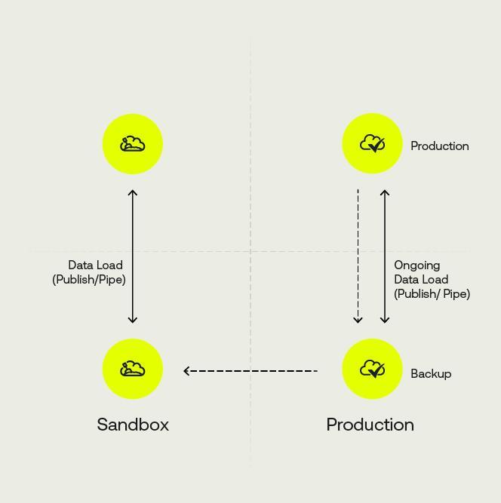
- Sandbox
Kyriba can be delivered with a test system per customer instance to facilitate side work and testing, as well as further phases’ setup, acceptance and promotion to the production instance. It consists of a regular copy of the Production platform with all data and users being carried over to this independent supplemental URL. All users are by default deactivated, receive the same rights and data access as in Production.
Once activated, all Cash, Payment and Risk user license tokens can access the sandbox platform with their same user and password, provided they have been reactivated by their administrators on
this platform.

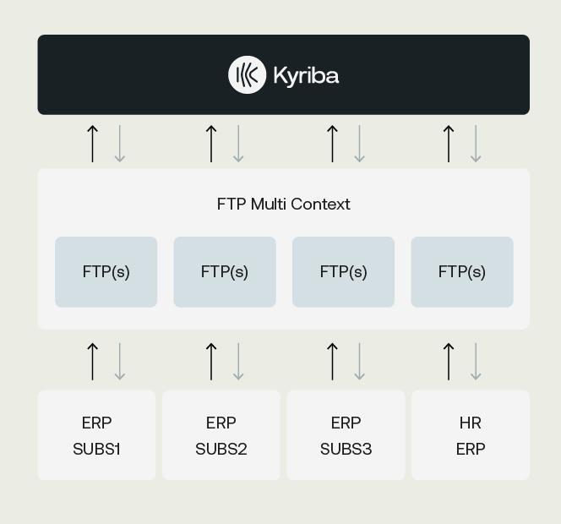
- FTP Multi Context [also in Kyriba for Mid-Market]
Kyriba’s multi-context FTP enables companies to set up a single FTP gateway with multiple in/out folders targeting different client’s systems. Third party system connecting to Kyriba can thus target a single FTP IP address but with individual folders (“accounts”) to ensure data exchanges confidentiality.
As an example, this option prevents a subsidiary of a Kyriba customer HQ from accessing data exchanged by another company as their data delivery tunnel will be segregated. Multi-context FTP can also be used to manage exchanges between geographically distinct third party systems or unrelated service providers (such as two different external HR and payroll service providers): in this case, each system or services provider stands for a unique inbound/outbound set of folders within the multi-context FTP server.
Sources of data include all Kyriba data which can be imported or exported in file.

- Security Package [also in Kyriba for Mid-Market
Kyriba’s Security Package leverages previously independent features into a consistent multi-tier Security solution which will evolve over time as new data protection and other operational risk mitigation measures are added. It currently consists of the four following features:
IP Filtering
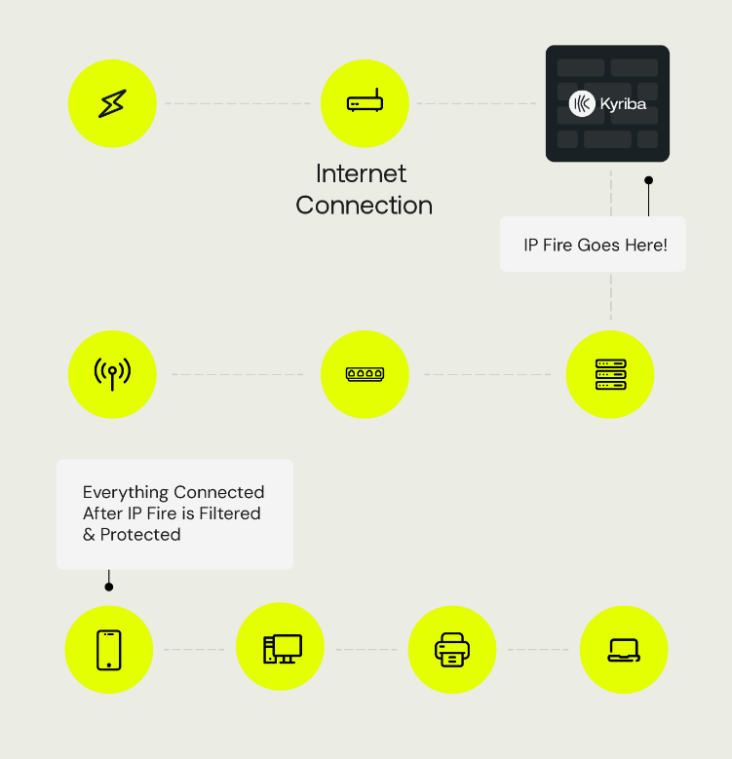
IP filtering is a security feature that allows clients to restrict login to a pre-defined set of IP addresses – or ranges of addresses – which are set up and maintained by the system security administrator. If used on its own, IP filtering is an effective fraud prevention tool by forbidding any unregistered IP to access a key system like Kyriba.
IP filtering can also be used in combination with other Kyriba security capabilities – for example any user logging in outside of the pre-defined set of IP addresses is required to use dual-factor authentication.
Once activated, all Primary and Secondary Cash, Payment and Risk user license tokens can access this function, even though it will be activated on super-users’ or administrators’ profiles only.

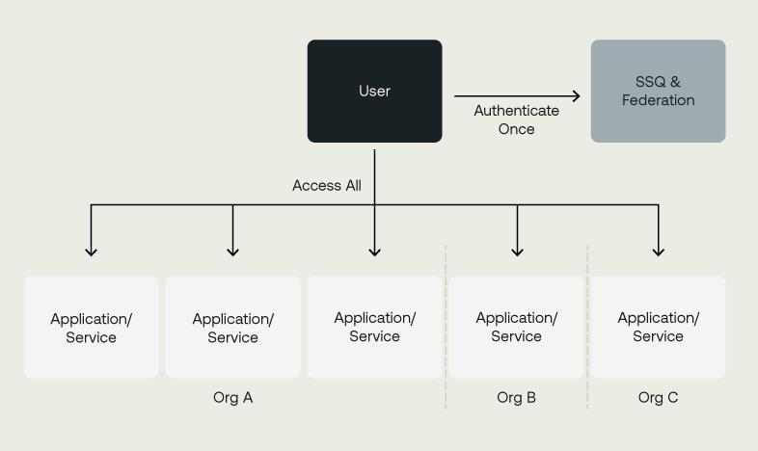
Enterprise SSO
This option allows Single Sign-On with a client’s internal security environment (or Lightweight Directory Access Protocol, LDAP). Kyriba's Enterprise SSO option uses the latest accepted security practice on the matter: SAML 2.0 for LDAP authentication. This option means that each user’s security credentials (for example, their Windows user ID and password) can be used to log in to Kyriba and drive user access within Kyriba.
With Kyriba’s Enterprise SSO, no additional user ID and password is required, and all password controls are managed internally by the corporate IT team and policies. It is an effective tool for day-to-day user administration and fight against internal fraud, allowing immediate deactivation of suspected fraudsters on all SSO-enabled systems

Multi-Factor Authentication
Multi-Factor Authentication (“MFA”) with Yubikey, SWIFT 3SKey or X509 certification compliant device, user-specific certificate and one-time password via SMS (and backup) are advanced security functionalities in Kyriba, notably for payment signatories. Kyriba Multi-Factor Authentication helps protect user accounts from unauthorized access to Kyriba if someone has managed to steal your password. When multi-factor authentication is activated, the user is prompted to enter the one-time password after submitting their normal user ID and password.
Multi-Factor Authentication is an optional procedure and includes:
- An activation at general or user level
- User Access Codes can expire after a defined session timeout period
- The second factor can also remain valid for a specific period of time
- MFA can be disabled for users who log from a trusted IP.
Multi-Factor Authentication has however become a requirement for all users activated within Kyriba’s Payment module when using a SWIFT Alliance Lite 2 or Service Bureau connection.
Sources of data include user MFA setup only.
Applicable functions include user certification at logon.
Licensed MFA users have access to the digital logon certificate entry screen.
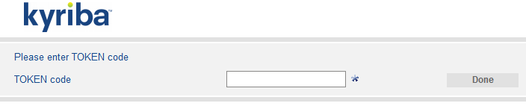



Control center
Kyriba's interface control centre fully audits all interface actions, including all error events, process failures and repair actions performed, so that the user enjoys full transparency and control over the Kyriba side of bank communications. It is possible to see in standard reports whether a bank statement (even on SWIFT network) has failed to upload or if an expected number of statement files has not yet been fully integrated.
The control center can be used for early detection of unauthorized usage and potential fraud. It offers the ability to monitor and analyse:
- Bank connectivity failures, including files expected, but not received;
- Payment files where final acknowledgement was not received;
- Escalation and summary of pending workflow approvals;
- Real-time status alerts of additions, deletions or modifications of data;
- Red/Yellow/Green status for workflow, data and task monitoring.
Sources of data include imported and exported files of any kind managed by the application.
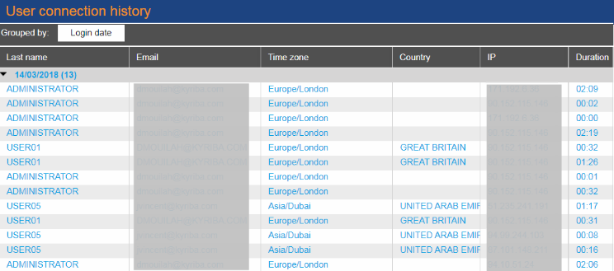
Applicable functions include expected file check definition; advanced reporting. This function is notably applicable to imported bank statements for daily automated emailed report of all received and missing bank statements.
Licensed Control Center users have access to the file check setup, the definition of and the run access to those reports.

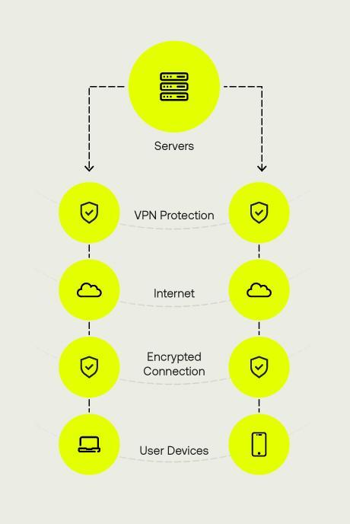
- Virtual Private Network (VPN)
Kyriba can set up and maintain a virtual private network (VPN), for each client so that users only access Kyriba through a dedicated network maintained by Kyriba. The VPN is ideal for centralized or regionalized treasury teams.
Kyriba's VPN tunnel ensures end-to-end privacy and protects sensitive data from would-be hackers. Pre-shared key confirms each VPN’s identity before connection is established to maintain security. All information is then delivered through the secure encrypted tunnel between Kyriba and client sites.
Kyriba’s VPN is commonly used in combination with IP filtering and dual factor authentication to customize the level of protection for both centralized and decentralized users.

Services
- Multiple Support Centers
Kyriba provides Client Support Services from a dedicated team of Kyriba specialists, who are physically located at our service centres in London, Paris, Warsaw, New York, San Diego, Tokyo and Singapore. All of Kyriba’s support staff are dedicated to supporting Kyriba. Kyriba’s single product focus ensures that system knowledge is not diluted across multiple systems. This leads to the efficient resolution of client issues, which means that Kyriba’s clients spend more time using the system as it is intended and less time trying to resolve system issues. A single contact per client is recorded in Kyriba’s CRM, ensuring all support communication is channelled through this chosen person (or his/her backup).
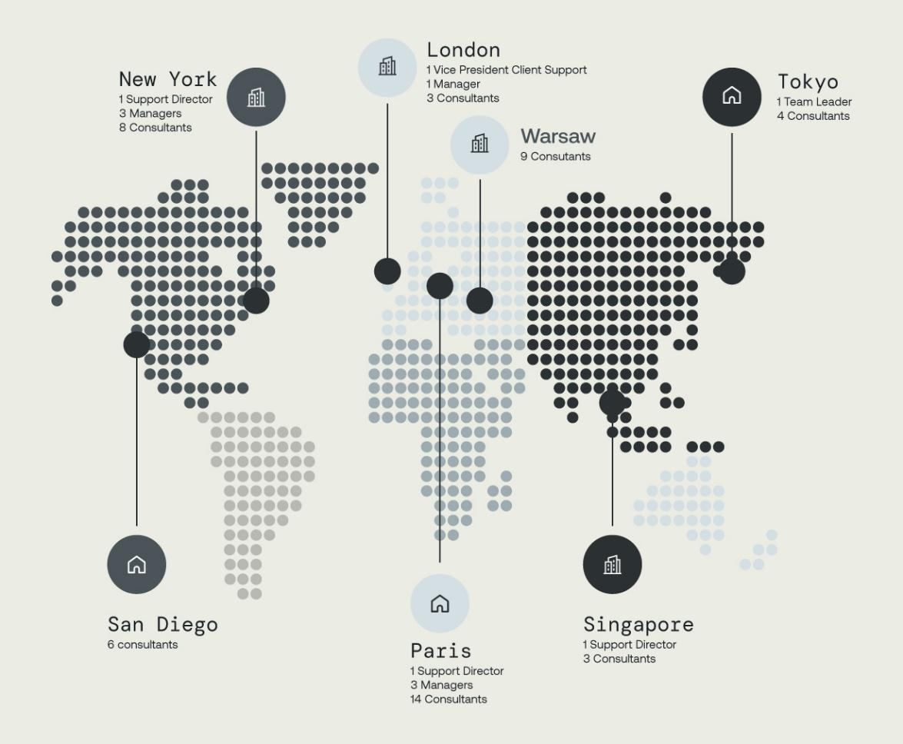
Kyriba’s Multi-Support Centers option allows our clients to receive support from more than one support centres (Americas, EMEA and Asia) and expand their number of recognized contacts in each region covered (up to 6 in total). Regional support contacts have access to their region Kyriba support centers during the standard primary hours applied in the region.

- Premium Support
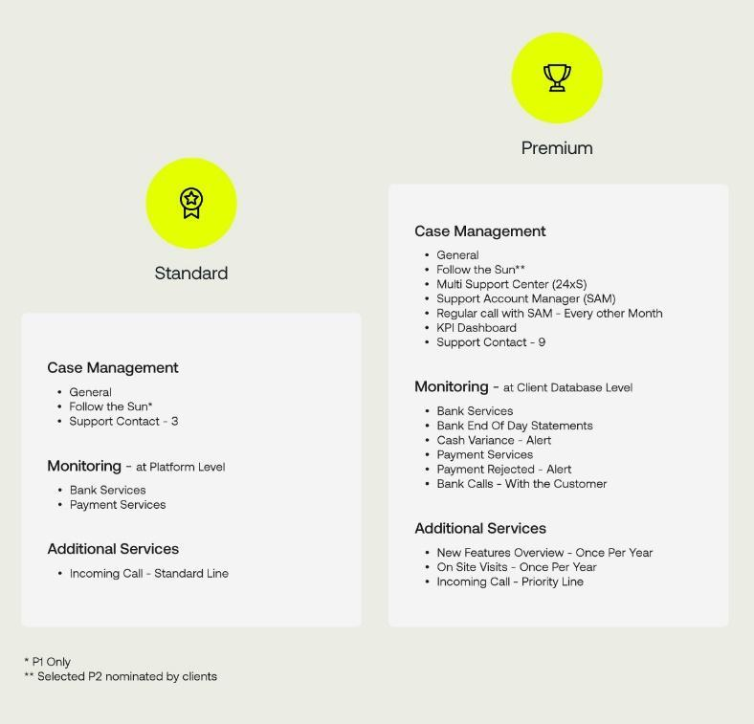
With Kyriba's Premium Support option, each client can be allocated to a Kyriba Support Account Manager ('SAM') to streamline communications and ensure a clear point of ownership for client-reported incidents. In this case, a client's SAM is the main point of contact for all support incidents, and manages communication with Kyriba Product Support, Software Development and Technical Consultants to achieve resolution of clients' issues. Having one dedicated point of contact ensures that Kyriba SAMs have an understanding of individual clients' business and use of Kyriba.
Customers are by default allocated to a single support desk with knowledge of setup and issues shared between the local support manager and consultants. The premium support option allows for up to 9 support contacts to reach Kyriba Global support centres.

- Platinum Support
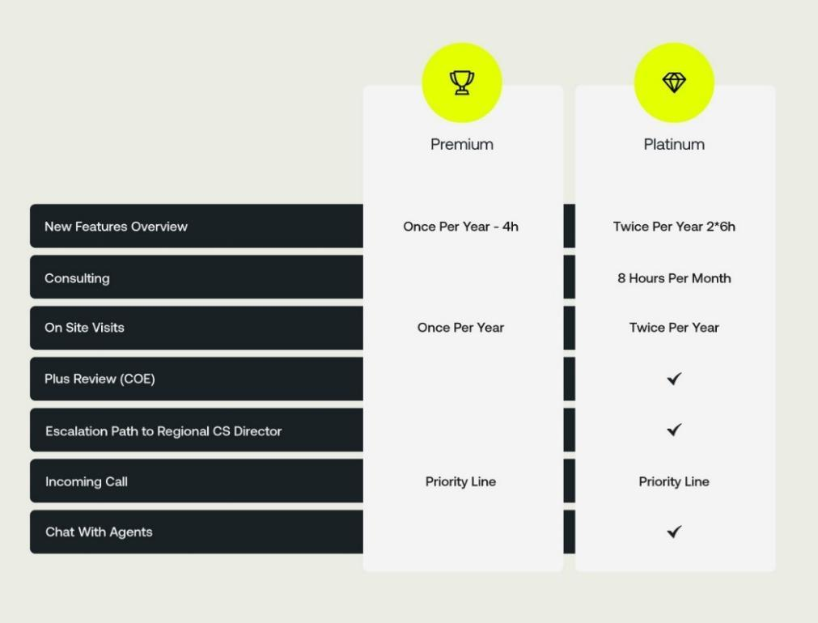
An upgrade from our Premium Support offering, this option entitles our client to designate fifteen points of contact in total who can reach out Kyriba support staff. This option also includes individualized and customized monitoring, one dedicated phone number and mobile, a yearly platform utilization (Platform Utilization Survey) session, eight hours of functional assistance and/or user training a month, and two on-site visits a year. The price and scope of the individualized and customized monitoring is determined during a workshop with the client (can be on site or remotely). The monitoring might include things like bank connection status, bank cash balance variances, monitoring of bank rejected transactions, action on scheduled communication in case of bank integration delays, proactive communication to dedicated contacts, payment transmission monitoring prior to bank cut-off time and ACK level monitoring, Sandbox monitoring set-up and test assistance.
The PLUS review session includes a functional analysis of the client’s existing setup, Kyriba solution optimization, current reporting analysis, menu map optimization, security review and a PLUS meeting report and best
practice recommendations.

- Enhanced Security Services
As part of Kyriba’s data protection promise to our customers, additional services are available to further the guarantees and access to our infrastructure and Security Office. The Enhanced Security Services include
the following:
- Completion of an annual security questionnaire submitted by the customer, within a 30-day
annual window;
- A single annual penetration testing of the Kyriba application (blind, white-box) on a
pre-production environment;
- An annual customer audit of Kyriba, covering change management, incident management, backups, disaster recovery testing, vulnerability management, patching and security awareness training.

- Appendix
- Kyriba for Mid-Market and Kyriba Enterprise solution scope differences
Pillars and Modules | Enterprise | Kyriba for Mid-Market
Treasury Management
Cash and Liquidity Management
Cash Management and Forecasting | ✔ | Cash & Liquidity Core
Advanced Forecasting | ✔ | Cash & Liquidity Options
In House banking | ✔ | Cash & Liquidity Core
Cash Accounting | ✔ | Cash & Liquidity Core
GL Reconciliation | ✔ | Cash & Liquidity Options
Bank Relationship Management
Bank Account Management | ✔
Bank Fee Analysis | ✔
Business Intelligence for Cash
Cash Analytics | ✔ | Global options
Cash Management AI | ✔
Other notable options
Bank Statement Forwarding | ✔ | Global options
Bank Reporting - Concentrator | ✔ | Cash & Liquidity Core
Market Data (Standard) | ✔ | Cash & Liquidity Options
Blackrock MM Connector | ✔ | Cash & Liquidity Options
ICD MM Integration | ✔ | Cash & Liquidity Options
Goldman Sachs Mosaic Integration | ✔ | Cash & Liquidity Options
Payments
Payment Management
Payments | ✔ | Payments Core
Payment Factory | ✔ | Payments Core
Direct Debit | ✔ | Payments Options
SEPA Mandates | ✔ | Payments Options
Netting | ✔
Draft Payables | ✔
Draft Receivables | ✔
Payment Builder | ✔
Fraud Management
Fraud Detection | ✔ | Payments Options
Fraud Screen data volume | ✔ | Payments Options
Payment Screening | ✔ | Payments Options
Payment anomaly detection using ML | ✔
Bank Account Validation | ✔ | Payments Options
Data & Analytics for Payment, Fraud & Compliance
Payment Analytics | ✔ | Global options
Compliance Analytics | ✔ | Global options
Other notable options
Control center | ✔
SWIFT Bank Directory Plus | ✔
Bank Payments - Concentrator | ✔ | Payments Core
Payment: Digital Signature | ✔ | Global options
Multi-Factor Authentication | ✔ | Global options
Risk Management
Risk Management and Financial Transactions
Position Keeping | ✔ | Cash & Liquidity Options
EMIR Reporting | ✔
Valuation | ✔
Hedge Accounting | ✔
Financial Accounting | ✔
Risk Analysis | ✔
Credit Risk | ✔
Leases | ✔
Data & Analytics for Risk
Risk Analytics | ✔ | Global options
Liquidity Analytics | ✔ | Global options
Other notable options
Premium Market Data | ✔
Premium Market Data for Risk | ✔
Premium Market Data for advanced Risk | ✔
Advanced FX Valuation - FinCAD | ✔
Advanced Rates Valuation - FinCAD | ✔
Premium Cap/Floor Implied Volatilities | ✔
CaaS Connector – CME Term SOFR | ✔
Working Capital
Trade Solutions
Reverse Factoring | ✔
Reverse Factoring - Financing Fees | ✔
Dynamic Discounting | ✔
Dynamic Discounting - Discount Earning Fees | ✔
Receivables Financing – Core | ✔
Receivables Financing – Discount Earning Fees | ✔
Supplier On boarding Solutions
Supplier Onboarding - Web site | ✔
Supplier Onboarding - Emailing | ✔
Supplier Onboarding - Reporting | ✔
Data & Analytics for SCF
SCF Analytics | ✔
Connectivity Solutions
Bank Connectivity
Bank Reporting - Concentrator | ✔ | Cash & Liquidity Core
Bank Reporting | ✔ | Cash & Liquidity Core
Bank Payments | ✔ | Payments Core
Bank Payments - Concentrator | ✔ | Payments Core
SWIFTNET Service Bureau | ✔
SWIFTNET AL2 Service | ✔ | Global options
Local and regional networks subscriptions | ✔
Advanced Bank Payments Connector | ✔ | Global options
Advanced Bank Reporting Connector | ✔ | Global options
ERP Connectivity
ERP Connector - SAP | ✔
ERP Connector - Oracle | ✔
NetSuite API Connector | ✔ | Cash & Liquidity Core
API-based value-add connectors
API platform | ✔ | Global options
Open Reports Studio | ✔ | Global options
Technical Process token | ✔ | Global options
Setup and Impact fees
SWIFTNET Setup | ✔
SWIFTNET AL2 Setup | ✔ | Global options
Bank Reporting Volumes | ✔ | Cash & Liquidity Core
ERP Transactions Volumes | ✔ | Cash & Liquidity Core
Payment Volumes | ✔ | Payments Core
Additional Options
Architecture and Security
Sandbox | ✔ | Global options
FTP Multi Context | ✔ | Cash & Liquidity Core
Security Package | ✔ | Global options
Services
Multiple Support Centers | ✔
Premium Support | ✔
Platinum Support | ✔
Enhanced Security Services | ✔
Premium Security Services | ✔

- List of all modules currently available in Kyriba
Internal Code | Module
 | Cash And Liquidity Management
PC01-0001 | Cash Management and Forecasting
PC01-0002 | In House banking
PC01-0003 | Cash Accounting
PC01-0004 | GL Reconciliation
PC01-0005 | Cash and Liquidity Primary Users
PC01-0006 | Cash and Liquidity Secondary Users
PC01-0008 | Advanced Forecasting
PC01-0012 | Affiliate Users
PC01-0013 | BI for Cash
PC01-0014 | BI Visual for Cash
PC01-0016 | BI for Liquidity Analytics
 | Bank Relationship Management
PC02-0001 | Bank Account Management
PC02-0002 | Bank Fee Analysis
PC02-0003 | Bank Relationship Primary Users
PC02-0004 | Bank Relationship Secondary Users
 | Payment Management
PC03-0001 | Payments
PC03-0002 | Payment Factory
PC03-0003 | Direct Debit
PC03-0004 | Draft Payables
PC03-0005 | Draft Receivables
PC03-0006 | SEPA Mandates
PC03-0007 | Multilateral Netting
PC03-0008 | Payment Primary Users
PC03-0009 | Payment Secondary Users
PC03-0011 | Sanction List Screening by Fircosoft (up to 100 payments)
PC03-0012 | Sanction List Screening by Fircosoft (up to 500 payments)
PC03-0013 | Sanction List Screening by Fircosoft (up to 2,000 payments)
PC03-0014 | Sanction List Screening by Fircosoft (up to 10,000 payments)
PC03-0015 | Sanction List Screening by Fircosoft (up to 30,000 payments)
PC03-0016 | Payment Builder
PC03-0017 | BI for Payment
PC03-0018 | BI Visual for Payment
PC03-0020 | Invoice Selector
PC03-0021 | Invoice Selector - User
PC03-0023 | Cross border FX nuisance payments
 | Risk Management and Financial Transactions
PC04-0001 | Debt Position Keeping
PC04-0002 | Foreign Exchange Position Keeping
PC04-0003 | Investments Position Keeping
PC04-0004 | Interest Rate Position Keeping
PC04-0005 | Financial Transactions Primary Users
PC04-0006 | Financial Transactions Secondary Users
PC04-0008 | EMIR Reporting
PC04-0012 | Commodities Position Keeping
PC05-0001 | Debt Valuation
PC05-0002 | Foreign Exchange Valuation
PC05-0003 | Investments Valuation
PC05-0004 | Interest Rate Derivatives Valuation
PC05-0006 | Foreign Exchange Hedge Accounting
PC05-0007 | Interest Rate Hedge Accounting
PC05-0008 | Debt Financial Accounting
PC05-0009 | Foreign Exchange Financial Accounting
PC05-0010 | Investments Financial Accounting
PC05-0011 | Interest Rate Derivatives Financial Accounting
PC05-0012 | Risk Management Primary Users
PC05-0013 | Risk Management Secondary Users
PC05-0015 | Risk Analysis
PC05-0016 | Credit Risk
PC05-0017 | FX Valuations 10
PC05-0018 | FX Valuations 50
PC05-0019 | FX Valuations 100
PC05-0020 | FX Valuations Plus
PC05-0021 | FX Hedge Accounting 10
PC05-0022 | FX Hedge Accounting 50
PC05-0023 | FX Hedge Accounting 100
PC05-0024 | FX Hedge Accounting Plus
PC05-0025 | FX Risk Analysis 10
PC05-0026 | FX Risk Analysis 50
PC05-0027 | FX Risk Analysis 100
PC05-0028 | FX Risk Analysis Plus
PC05-0029 | Interest Rate Valuations 5
PC05-0030 | Interest Rate Valuations 10
PC05-0031 | Interest Rate Valuations 20
PC05-0032 | Interest Rate Valuations Plus
PC05-0033 | Interest Rate Hedge Accounting 5
PC05-0034 | Interest Rate Hedge Accounting 10
PC05-0035 | Interest Rate Hedge Accounting 20
PC05-0036 | Interest Rate Hedge Accounting Plus
PC05-0037 | Interest Rate Risk Analysis 5
PC05-0038 | Interest Rate Risk Analysis 10
PC05-0039 | Interest Rate Risk Analysis 20
PC05-0040 | Interest Rate Risk Analysis Plus
PC05-0045 | BI for Risk
PC05-0046 | BI Visual for Risk
PC05-0048 | Leases 500
PC05-0049 | Leases 1000
PC05-0050 | Leases 5000
PC05-0051 | Advanced FX Valuation - FinCAD
PC05-0052 | Advanced Rates Valuation - FinCAD
PC05-0053 | Premium Cap/Floor Implied Volatilities 01 - USD
PC05-0054 | Premium Cap/Floor Implied Volatilities 01 - EUR
PC05-0055 | Premium Cap/Floor Implied Volatilities 01 - GBP
PC05-0056 | Premium Cap/Floor Implied Volatilities 01 - CAD
PC05-0057 | Premium Cap/Floor Implied Volatilities 01 - CHF
PC05-0058 | Premium Cap/Floor Implied Volatilities 01 - DKK
PC05-0059 | Premium Cap/Floor Implied Volatilities 01 - JPY
PC05-0060 | Premium Cap/Floor Implied Volatilities 01 - NOK
PC05-0061 | Premium Cap/Floor Implied Volatilities 01 - SEK
PC05-0062 | Premium Cap/Floor Implied Volatilities 01 - CZK
PC05-0063 | Premium Cap/Floor Implied Volatilities 01 - PLN
PC05-0064 | Commodities Valuations (1-5 transactions)
PC05-0065 | Commodities Valuations (6-10 transactions)
PC05-0066 | Commodities Valuations (11-20 transactions)
PC05-0067 | Commodities Valuations (20+ transactions)
PC05-0068 | Commodity Derivatives Financial Accounting
PC05-0069 | Commodity Derivatives Valuation
PC05-0070 | Commodities Hedge Accounting
PC05-0071 | Commodities Hedge Accounting (1-5 transactions)
PC05-0072 | Commodities Hedge Accounting (6-10 transactions)
PC05-0073 | Commodities Hedge Accounting (11-20 transactions)
PC05-0074 | Commodities Hedge Accounting (20+ transactions)
 | Trade Solutions
PC06-0001 | Supply Chain Finance - Dynamic Discounting
PC06-0002 | Supply Chain Finance - Reverse Factoring
PC06-0004 | Reverse Factoring - Financing Fees
PC06-0005 | Dynamic Discounting - Discount Earning Fees
PC06-0006 | Supplier Onboarding - Web site
PC06-0007 | Supplier Onboarding - Emailing
PC06-0008 | Supplier Onboarding - Reporting
PC06-0009 | BI for SCF
PC06-0010 | BI Visual for SCF
PC06-0013 | Receivables Finance - Core Earning Fees
PC06-0015 | Receivables Finance - Core
 | Connectivity
PC07-0001 | Bank Reporting - Concentrator
PC07-0002 | Bank Payments - Concentrator
PC07-0003 | Bank Reporting
PC07-0004 | Bank Payments
PC07-0006 | SWIFTNET Service Bureau
PC07-0007 | SWIFTNET AL2 Service
PC07-0008 | FIRST Subscription
PC07-0009 | Editran Subscription
PC07-0010 | CBI Subscription
PC07-0014 | NetSuite Bridge
PC07-0016 | BACS Subscription
PC07-0017 | Chinese Banks Connectivity - Bank Reporting
PC07-0018 | Chinese Banks Connectivity - Payments
PC07-0020 | BACS Credit/Direct Debit Onboarding Fee
PC07-0021 | BACS Credit/Direct Debit Volume Based Fee
PC07-0022 | DDMS Subscription
PC07-0023 | Bacs DDMS Onboarding Fee
PC07-0024 | BACS DDMS Volume Based Fee
PC07-0025 | DCA Faster Payments Subscription
PC07-0026 | DCA Faster Payments Onboarding Fee
PC07-0027 | DCA Faster Payments Volume Based Fee
PC07-0028 | API Platform
PC07-0029 | ERP Connector - SAP S/4 HANA
PC07-0030 | ERP Connector - SAP ECC
PC07-0031 | ERP Connector - Oracle Financials Enterprise Business Suite (EBS)
PC07-0032 | ERP Connector - Oracle Financials Cloud
PC07-0033 | ERP Connector - Dynamics 365 Finance
PC07-0034 | Advanced Bank Payments Connector
PC07-0035 | Advanced Bank Reporting Connector
 | Connectivity options
PC10-0001 | Bank Reporting Volumes
PC10-0002 | ERP Transactions Volumes
PC10-0003 | Payment Volumes
PC16-0001 | SWIFTNET Setup
PC16-0003 | SWIFTNET AL2 Setup
 | Options
PC08-0001 | SWIFT Bank Directory Plus
PC08-0003 | Payment: Digital Signature
PC08-0004 | IP Filtering
PC08-0006 | Market Data (Standard)
PC08-0010 | Multi-Factor Authentication
PC08-0011 | VPN Access
PC08-0012 | Premium Support
PC08-0013 | Sandbox
PC08-0014 | Multiple Support Center
PC08-0015 | FTP Multi Context
PC08-0017 | Enterprise SSO
PC08-0018 | Platinum Support
PC08-0019 | Bank Statement Forwarding
PC08-0020 | Premium Market Data (max 380 MD)
PC08-0021 | Premium Market Data for Risk (max 700 MD)
PC08-0022 | Premium Market Data for advanced Risk (max 1400MD)
PC08-0025 | Enhanced Security Services
PC08-0028 | BI Visual for Compliance
PC08-0029 | Security Package
PC08-0030 | Support Add-on - Advanced Monitoring
PC08-0031 | Support Add-on - Designated support contact
PC08-0032 | Support Add-on - Monitoring
PC08-0033 | Support Add-on pack of additional 5 support contacts
 | Fraud Management
PC09-0001 | Fraud Detection
PC09-0002 | Fraud Screen data volume
PC09-0003 | Fraud Primary Users
PC09-0004 | Fraud Secondary Users
PC09-0007 | Payment Anomaly detection using Machine Learning
PC09-0008 | Bank Account Validation: SIS-id Connector
PC09-0009 | Bank Account Validation: Trustpair Connector
PC09-0010 | Bank Account Validation: Giact Connector
 | FiREapps - Balance Sheet
PC19-0001 | Balance Sheet Base Platform
PC19-0002 | FiREapps for SAP Exposure Extract
PC19-0003 | FiREapps for Oracle Exposure Extract
PC19-0004 | FiREapps for JD Edwards Exposure Extract
PC19-0005 | FiREapps for PeopleSoft Exposure Extract
PC19-0006 | Manual Exposure Data Capture
PC19-0007 | Transform Enabled ERP/Datasource Connections
PC19-0008 | Automated Forecast Generation
PC19-0009 | Decision Support
PC19-0010 | Trade Aggregation, Netting and Allocation
PC19-0011 | TMS/Trading Platform Connections
PC19-0013 | Standard FiREapps Business Intelligence Suite
PC19-0014 | FX Gain/Loss Advanced Analytics (Daily Rate)
PC19-0015 | Multi-Currency Data Integrity Analytics
PC19-0016 | Hedge Performance Analysis (Hedge Effectiveness)
PC19-0017 | CoRE Analysis
PC19-0029 | Correlated VaR Decisions
 | FiREapps - Cash Flow
PC20-0001 | Cash Flow Base Platform
PC20-0002 | FIREapps for SAP Exposure Extract
PC20-0003 | FIREapps for Oracle Exposure Extract
PC20-0004 | Manual Exposure Data Capture
PC20-0005 | Transform Enabled ERP/Datasource Connections
PC20-0006 | TMS/Trading Platform Connectivity
PC20-0007 | Trade Netting & Allocation (Includes Decision Support, TMS & TP Connections)
PC20-0009 | Starter Kit of BI Analytics
PC20-0010 | Forecast to Actual
PC20-0011 | Cash Flow Platform Users
PC20-0012 | Cash Flow Decision Support
 | BlackRock Online
PC23-0001 | BlackRock Enterprise SSO

PC23-0002 | BlackRock Investments Position Keeping
PC23-0003 | BlackRock Primary Users
PC23-0004 | SSO for ICD Integration



t
Liquidity
Performance

Build resilience, generate value,
and unlock growth.

kyriba.com

50 accounts by default using the Concentrator service. Additional option to extend to 200 accounts
50 accounts by default using the Concentrator service. Additional option to extend to 200 accounts
Debt, Investment and Foreign Exchange Position Keeping available as three distinct add-ons
50 accounts by default using the Concentrator service. Additional option to extend to 200 accounts
3 banks by default. Additional option to extend to 5 banks
3 banks by default. Additional option to extend to 5 banks
50 accounts by default using the Concentrator service. Additional option to extend to 200 accounts
10,000 transactions a month by default. Additional option to extend to 20,000 transactions
10,000 transactions a month by default. Additional option to extend to 20,000 transactions
10,000 transactions a month by default. Additional option to extend to 20,000 transactions

